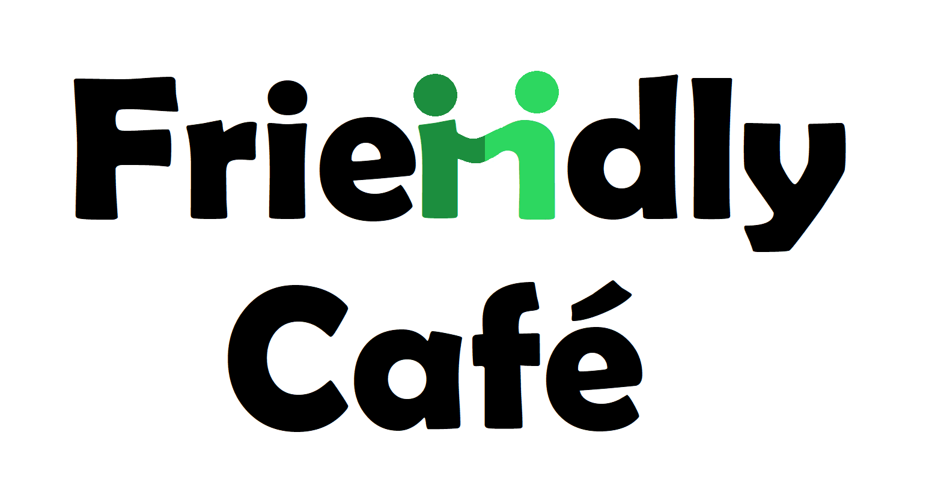

Often, we go to a café and are sat near others who
would like to have someone to talk to, but who
may be afraid to ask, or want to respect others privacy.

The Friendly Café Scheme allows people the chance to have a drink and a chat with someone
else in the same position.

The following cafes are taking part in this scheme so why not go along and meet someone new:

Bap (46 Haymarket Mill Gate Shopping Centre, Bury BL9 0BX – Mondays, Tuesdays, Thursdays and Sundays)

Automatic at The Met (Derby Hall Market Street, Bury BL9 0BW – 10am-12pm and 2pm-4pm, Mondays, Tuesdays, Fridays)

Tristians Traditional Family Restaurant (21 Princess Parade, Bury BL9 0QL – 930am-330pm, Mondays, Tuesdays and Fridays)

