OUR VISION

Our commitment as a provider of high quality, personalised support services is to promote and enable you to take control of your life and gain more independence at a pace that suits you.
We are committed to having an honest, open, approachable and person centred culture so that you can grow in the way you want to and know we are there when you need us – we do what we say and say what we do!
We are committed in finding local teams of support workers that will work best with you and for you. Wherever possible, you can be involved in the recruitment and selection of a team for your support package

OUR MISSION
Stepping Stones Services aims to provide high quality care in a homely and friendly atmosphere. At Stepping Stones Services our Promise to service users is to:
Ensure you are included in decisions with every aspect of your support, providing a support worker who has similar interests and values and is trained to meet your health and welfare needs
Respect your individuality, your rights and choices whilst maintaining your Independence.
Help others understand how to support you in this way
Ensure you are informed with the right information to make best choices
We want to help you have and maintain personal relationships, to support you
To meet new people in whatever settings you choose as well as have holidays and breaks of your own choice
Support you to live safely and to have a warm and comfortable environment
To make sure your medication is well managed and documented
To access healthcare and obtain relevant advice in the area where you live
To support you with your mental and spiritual wellbeing
Uphold the human and citizenship rights of all who we support, and who visit them.
Recognise the individual uniqueness of Service Users and visitors and treat them with dignity and respect at all times.
Respect individual requirement for privacy at all times and treat all information relating to individuals in a confidential manner.
Recognise the individual need for personal fulfilment and offer individualised programmes of meaningful activity to satisfy that need of Service Users.
Our Philosophy
Stepping Stones Services philosophy of care:
All people who are involved Stepping Stones Services be they employees, clients or visitors will be treated with respect at all times.
We offer skilled care to enable people who we support to achieve their optimum state of health and well-being.
We uphold the human and citizenship rights of all who are supported by us or work for Stepping Stones.
Individual choices and personal decision-making are the right of all Service Users and will be upheld by all the people who work at Stepping Stones Services.
The right of independence will be respected and encouraged for all Service Users.
The individual uniqueness of Service Users and visitors will be recognised. They will be treated with dignity and respect at all times.
The individual requirement for privacy will be respected at all times and all information relating to individuals will be treated in a confidential manner.
We recognise the individual need for personal fulfilment and aim to offer personalised programmes of meaningful activity to satisfy the requirements of the Service User.
Who can use our service
We can provide a personalise service to
- Adults who have Mental health issues
- Adults who have physical disabilities
- Adults who have substance abuse issues
- Adults who have sensory impairments
- Adults who have Dual diagnosis
- Older people needing support in their own home
- Any people needing specialist support
- Adults with forensic needs
- BME Groups

The services can we provide
- Specialist support for people with sensory impairments
- Complex needs support
- Behavioural support
- 24 hour support
- 1:1 individual support (what you need when you need it!)
- Respite
- Placements by compatibility
- Personalised support packages
- Palliative care
- Front door services and enablement
- Supported living
- Homecare/Outreach
- Outcome focused support plans
- Recovery based support

What kind of support we can offer
- To access health care services
- Personal care
- Independent living skills
- Developing new skills
- Gaining or maintaining employment
- Achieving personal goals and aspiration
- Accessing the community, amenities and services
- Maintain relationships and make new ones
- Budgeting, benefits and finances
- Diet and nutrition/healthy eating
- Meaningful activities and appropriate exercise
- Behavioural challenges
- Gaining and maintaining education placements
- Maintaining your tenancy
- Taking care of your own environment
- Companionship
- Assisted technology
Meet the Team

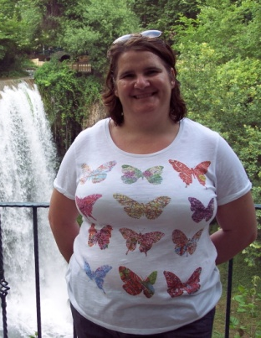
Suzanne Kirkbride
Registered Care Manager

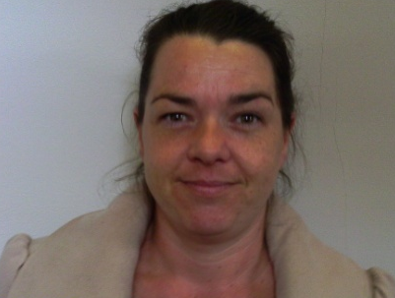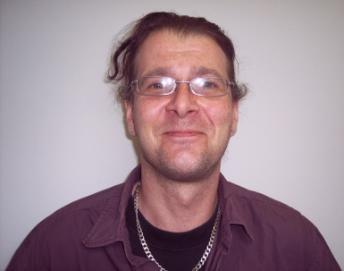

Our team of support workers
At Stepping Stones Services we believe that our support staff are at the heart of what we are trying to achieve. We recruit people who are positive and are passionate about people who need support. Our recruitment process is thorough to ensure we employ the right people and each member of our team has come through the DBS process. Our service users are involved in the recruitment processes
After the staff member has been employed they undergo full induction into the services and are assessed on their level of knowledge to determine what training they require and with the teams full support they are trained to be skilled and competent in their work practises to gain the best outcomes for those we support
Our Training includes
- Administration of medication
- Professional boundaries
- Person Centred planning
- Understanding Self Harm
- De-escalation training/Breakaway technics
- Safeguarding Adults
- Risk Management planning
- Personal Budgets and benefit support
- MCA & DOLS
- Communication & Confidentiality
- Mental Health Awareness
- Diet/nutrition
- Equality and Diversity
- Understanding CQC and legislation
- Health &Safety
- Food Safety
- First Aid
- Moving and Handling
- COSSH/Infection control
And any specialised training required for person centred support

Quality Assured Service
At Stepping stones services we work hard to achieve the best possible attainment under the Supporting People Quality Assessment Framework and to meet the outcomes set by the Care Quality Commission. We are proactive in improving our services through our internal auditing systems. Quality is also assured through our compliance with service specifications and the quality standards specified by purchasers.

We work with our service users, families, health professionals and purchasers to ensure continual improvement for out services

Your wellbeing
Here at stepping stones your well being is an extremely important to us
We will encourage you to help yourself by

- Connecting with others – building relationships

- Being Active – Going to the gym, going for walks any physical activity that you find enjoyable

- Keep Learning – Learning a new skill can give you a great sense of achievement

- Giving to others – by volunteering or even being kind to others can give you a good feeling

- take notice – be more aware of the present moment, including your feelings and thoughts, your body and the world around you. Some people call this awareness "mindfulness", and it can positively change the way you feel about life and how you approach challenges.

Recovery Support
Steppingstones services are focused on the recovery of our service users mental health we do this by implementing
The recovery process:
- provides a holistic view of mental illness that focuses on the person, not just their symptoms
- believes recovery from severe mental illness is possible
- is a journey rather than a destination
- does not necessarily mean getting back to where you were before
- happens in 'fits and starts' and, like life, has many ups and downs
- calls for optimism and commitment from all concerned
- is profoundly influenced by people’s expectations and attitudes
- requires a well organised system of support from family, friends or professionals
- requires services to embrace new and innovative ways of working.

How we do this is by supporting people to have
- good relationships
- financial security
- satisfying work
- personal growth
- the right living environment
- developing one’s own cultural or spiritual perspectives
- developing resilience to possible adversity or stress in the future.
- being believed in
- being listened to and understood
- getting explanations for problems or experiences
- having the opportunity to temporarily resign responsibility during periods of crisis.
Contact Information

Monday to Friday 9am to 5pm please contact;-
Registered Provider Arzoo Mahmood
Registered Manager Suzanne Kirkbride
Broadfield House
91 Manchester Road
Rochdale
OL11 4JG
TEL: 01706 759 993
FAX 01706 869 890
EMAIL: info@steppingstonesservices.co.uk
Or suzanne@steppingstonesservices.co.uk

EMERGENCY out of hours TEL: 07814 962 929

