Lentil and Beef Cottage Pie with Root Vegetable Mash
Method
- Heat the olive oil in a pan on a medium heat and add the onions. Let them brown slightly and then turn the heat to low. Add the spices and herbs
- Add the mince and cook for further 5-10 minutes.
- Add the lentils and cover the pan stirring occasionally. Cook for further 5-10 minutes. Add the stock and the tomato puree and mix until well combined. Continue simmering on a low heat.
- Heat the oven on 180c. Cut the root vegetables into small cubes and place in a pan with water. Bring to the boil. Reduce the heat and cover the pan with a lid. Let cook for about 15-20 minutes or until soft.
- Remove the water from the pan and use the milk and the butter to create a mash. Season with salt.
- Transfer the mince and lentil mix to a baking dish, level and then place the mash on the top levelling it. Place in the oven and cook until crispy and golden brown on the top.

Ingredients
1-2 tbsp olive oil
1 small onion (frozen ready chopped is also good)
Seasoning such as garlic, salt, pepper, and Italian herbs, bay leaf, rosemary
150g lean mince beef
1 cup red lentils or green lentils
1 cup beef or chicken stock
2 tbsp tomato puree
For the topping:
Cook a mixture of root vegetables such as potato, celeriac, parsnip, turnip or carrot and when soft mash with butter and whole milk.
----------------------------------------------------
Common allergens: milk
Estimated nutrition information per serving depending on the ingredients used:
520 calories
26 grams of protein

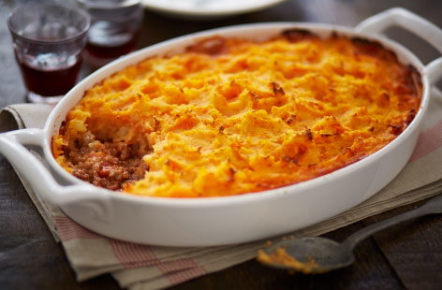

Corned Beef Hash with Greens and Baked Beans
Method
1.Put the potatoes in a pan, cover with cold water and bring to the boil. Cook for about 6-7 mins, then drain.
2.Heat the oil in a non-stick frying pan and cook the onion for 3-4 mins over a medium heat. 3.Add the potatoes and the greens and corned beef, and push down with a spatula to crisp up, cooking for about 5 mins. Turn the mixture over, trying not to break up the meat and potatoes too much, then add the Worcestershire or brown sauce. Cook for another 5 mins, pushing down to crisp the base again. Season a little, then serve with baked beans and a sprinkling of parsley if you like.

Ingredients
3-4 white potatoes
2 tbsp vegetable or olive oil
1 onion roughly chopped
Large handful of spring greens or spinach or kale
1 tin corned beef
2 tbsp Worcester sauce or brown sauce (optional)
------------------------------------------
Estimated nutrition information per serving depending on the ingredients used (including the baked beans):
750 calories
19 grams of protein

.

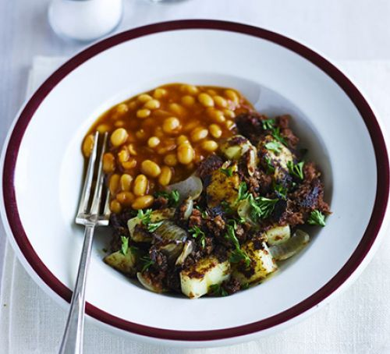

Bacon Broccoli Pasta Bake
Method
Preheat the oven on 180 Celcius. 1. Cook the pasta in a pan of salted water and olive oil. Leave the pasta slightly under cooked, drain and set aside. 2. Chop the broccoli florets into small pieces and set aside. 3. Now cut the bacon and set aside also. 4. Place the cooked pasta in a deep ovenproof dish. Add the sauce, the broccoli and the bacon and mix well until all is combined together. 5. Top with the cheese and breadcrumbs and bake in the oven until golden brown on the top.

Recipe
2tbsp olive oil
300g dry pasta shells
1 head of broccoli
100 grams unsmoked back bacon
1 jar ready made white pasta sauce
150g grated cheese
20 grams breadcrumbs
------------------------------------
Common Allergens: Milk
Estimated nutrition information per serving depending on the ingredients used:
310 calories
11 grams protein

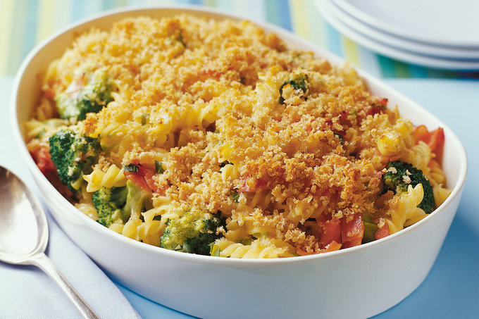

Tinned Sardines or Tinned Tuna Fishcakes
Method
1.Put the potatoes in a pan of salted cold water. Bring to the boil, then turn the heat down and simmer for 6-8 minutes or until tender. Drain well, leave to steam dry in the pan, then mash coarsely using a potato masher or the back of a fork.
2.Put the sardines or the tuna in a bowl, mash lightly with a fork, then add the spring onions or chives, egg, mustard, lemon zest, and the flour. Mix until combined, add the mashed potato, season generously with salt and black pepper, then mix again.
3.With lightly floured hands, shape the mixture into 8 even patties. Put each one on a plate as you work, then loosely cover and chill for 10 minutes.

4.Heat 1 tbsp of the vegetable oil in a large non-stick frying pan then fry half the fishcakes for 3-4 minutes on each side until golden and piping hot. Put on a plate and keep warm. Repeat with the remaining oil and fishcakes. Serve with salad and lemon wedges for squeezing over.
Ingredients
2-3 potatoes, peeled and chopped
2 tins of sardines or tuna in oil (drained)
4 spring onions or a handful of chives finely chopped
1 large egg, beaten
1 tbsp mustard
Zest of 1 lemon (optional)
50g plain flour
2 tbsp vegetable oil
---------------------------------------------------
Common Allergens: Milk, wheat, mustard
Estimated nutrition information per serving depending on the ingredients used:
310 calories
11 grams protein

Mild Chicken Korma and Rice
Method:
- Peel the onion and dice it. Take a medium sauce pan and heat the olive oil. Add the diced onion and stir gently over a medium heat.
- Peel the sweet potato and dice to small cubes and add to the olive oil and onion mix. Carry on cooking for about 10 minutes stirring regularly.
- Add the diced chicken and cook for further 5 minutes until the chicken pieces have changed to a white colour.
- Add the jar of korma sauce and let cook under a lid for 5-10 minutes.
- Boil the rice in the bag according to manufacturers instructions on the back of the packaging.

Recipe
1 tbsp olive oil
1 onion
1 small sweet potato, diced
200g diced chicken breast or tofu pieces if making a vegetarian version
1 jar ready-made mild Korma sauce
1 bag boil in the bag rice
--------------------------------------------
Common Allergens: Milk
Estimated nutrition information per serving depending on the ingredients used:
500 calories
30 grams protein

Sausage and Bean Stew
Method
1.Heat a large non-stick frying pan, then brown the sausages for 3-5 mins over a high heat. 2.Drain the beans, then add to the pan with the chopped tomatoes, herbs and sugar. Season well and bring to the boil. 3.Simmer for 10 mins until the sausages are cooked through and the sauce has thickened, coating the beans.

Ingredients
8 sausages (either frozen, tinned or fresh)
2 cans of mixed beans
2 tins of chopped tomatoes
1 tbsp dried Italian herbs
Salt and pepper to taste
----------------------------------------------
Estimated nutrition information per serving depending on the ingredients used:
420 calories
16 grams of protein

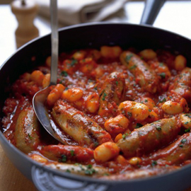

Chicken Noodle Casserole using tinned soup
Method
1.Preheat the oven to 180c. 2.In a medium saucepan, cover the chicken breasts with cold, salted water by 1 inch and bring to a low boil over medium-high heat. Simmer the chicken breasts until cooked through, 8 to 10 minutes. Remove the chicken out of the liquid and set aside to cool. Once the chicken is cool enough to handle, shred into small pieces. 3.Meanwhile, bring the cooking liquid back to a boil and cook the egg noodles until slightly underdone, 6 minutes. 4.In a medium bowl, mix together the shredded chicken, noodles, soups and the chicken stock. Season with salt and pepper. 5.Place the mixture into a lightly greased oblong or round pan or a casserole dish. 6.Crumble the bread over the top of the casserole, then pour the melted butter.
Ingredients
4 boneless, skinless chicken breasts or any other part of the chicken you have
1 pack of noodles 2 tins of creamy mushroom soup or creamy chicken soup
1 cup of prepared chicken stock
salt and pepper to taste
4 slices white bread
1 stick unsalted butter, plus more for greasing
-----------------------------------------------------
Common Allergens: Milk
Estimated nutrition information per serving depending on the ingredients used:
370 calories
40 grams protein

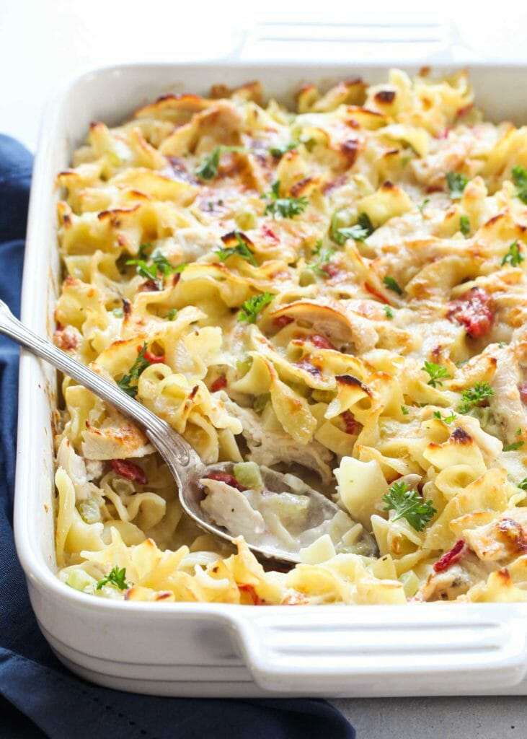
Corn Chowder
Ingredients
2 tbsp of olive, vegetable oil or butter 1 large onion, peeled and finely chopped 1 clove of garlic, peeled and crushed 2 sticks of celery, finely chopped (optional) 1tbsp flour 1 can of sweetcorn
1 large potato, peeled and cut into rough 1cm cubes 1 litre prepared chicken or vegetable stock
2tbsp chopped parsley
60ml double cream, single cream or whole milk (depending on how creamy you like it).
--------------------------------------------------
Common Allergens: Milk
Estimated nutrition information per serving depending on the ingredients used:
220 calories
8 grams protein

Method
1.Gently cook the onion, garlic and celery in the oil or butter for 4-5 minutes until soft. Stir in the flour and cook on a low heat for 1-2 minutes.
2.Add the potatoes followed by the sweetcorn and cook gently for about 5 minutes taking care it does not burn.
3.Gradually add the prepared chicken or vegetable stock, bring to the boil and simmer for 5 minutes. Season with salt and pepper and simmer for another 20 minutes before adding the cream or the milk.

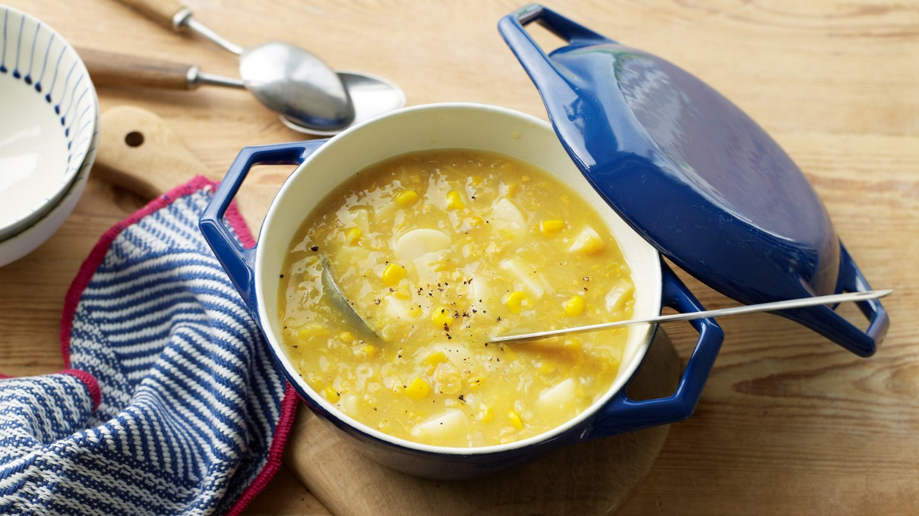
Griddled Peaches with Rice pudding Ice - cream

Method
1.Whisk the egg whites with the sugar in a mixing machine, by hand or with an electric hand whisk until stiff. Carefully fold the egg white into the rice pudding, transfer to a plastic container with a lid and place in the freezer for 4-5 hours, stirring occasionally until it is firm and frozen.
2.Reserve 4 peach halves and blend the rest until smooth in a liquidiser. You can skip this stage and just use all the peaches for frying.
3.To serve, heat a heavy or non-stick frying pan and fry the peaches, cut side down for 3-4 minutes, until they are nicely coloured. Spoon a little of the peach purée onto serving plates and place the peach on the purée, cut side up. Spoon or scoop out the rice pudding with the help of a spoon or ice-cream scoop dipped in hot water and place next to the peach.
-------------------------------------------------
Common Allergens: Milk
Estimated nutrition information per serving depending on the ingredients used:
300 calories
6 grams of protein

Ingredients
1 can of rice pudding
2 egg whites
2 tbsp caster sugar or
1 can of peach halves, drained

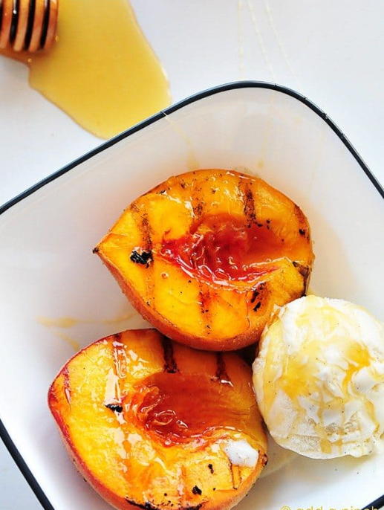

Cherry Pie
Ingredients
1 box ready made and rolled shortcrust pastry. (If you don’t have ready made shortcrust pastry you can make your own following any sweet pastry recipe).
2 tins of cherries or cherry pie filling
1 tsp milk
1 tsp sugar
--------------------------------------------------
Common Allergens: Milk
Estimated nutrition information per serving depending on the ingredients used:
300 calories
3 grams of protein

Method
1.Heat oven to 175Celcius. 2.Lay the pastry flat and using a dinner plate, cut round the plate to make two equal in size circles- one to go as the bottom of the pie and one as the top. 3.Spoon tinned cherries or cherry pie filling into crust-lined plate. Top with second crust; seal edge and flute. Brush top crust with milk and then sprinkle with sugar. Cut slits in several places on top crust. 4.Bake 40 to 45 minutes or until crust is golden brown. After 15 to 20 minutes of baking, cover crust edge with strips of foil to prevent excessive browning. Cool at least 1 hour before serving.

