Food First Recipes

Food first approach is designed for those who are at risk of malnutrition or who have lost weight without meaning to or have a low body weight.
The ‘Food First’ approach is at its basis a daily consumption of:
• 1 pint of fortified milk or a nourishing drink
• 2 nourishing snacks
• 3 fortified meals

Fortified Milk
Ingredients:
1 pint of full fat milk
4 tablespoons milk powder
Method:
Whisk ingredients together with a fork.
Use 1 pint daily for drinks or cereals or anything else you would be using milk for

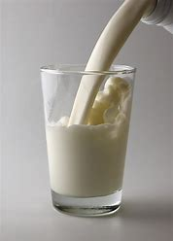

Strawberries and Cream Porridge
Ingredients
1/2 cup porridge oats
1/2 cup double cream 1/2 cup whole milk
1 handful chopped berries (strawberries, raspberries, blueberries, blackberries)
1/4 cup shelled sunflower seeds to sprinkle (optional)
Method
Put all of the ingredients, apart from the strawberries, into a saucepan and bring to a gentle boil over a medium heat, stirring often. When it reaches the boil reduce to a simmer for a few minutes and when it is starting to get thick pop the strawberries and seeds in for another 30 seconds. Remove from the heat and enjoy.

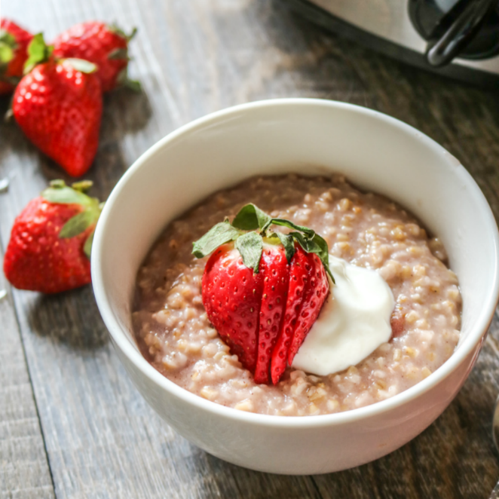

Fortified soup
Ingredients:
300ml tinned soup (tomato/mushroom/chicken/country vegetable/leek and potato)
3 tablespoons of whole milk
3 tablespoons milk powder
Method:
Mix the skimmed milk powder with a little milk to form a smooth paste. Heat the soup but do not boil, and slowly stir in the paste. Serve hot.

Velvety pea soup

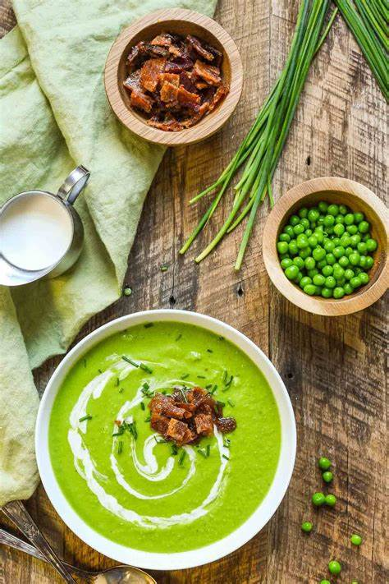
Ingredients:
2 cups of frozen peas
2 cups of stock or 2 cups of water with 2 stock cubes
240ml/1 cup of single cream
Salt and pepper to season
Method:
Put the stock and peas in a pan, bring to the boil and simmer for 2-3 minutes. Mix the contents of the pan with the cream and blitz with a blender of your choice. Add salt and pepper

Fortified mashed potatoes

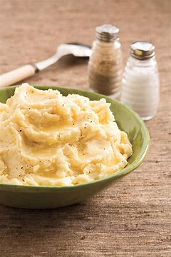
Method:
Add 1 tablespoon grated full fat cheese and 2 teaspoons of butter/margarine to one scoop of mashed potato (already mashed in the kitchen with whole milk, double cream and butter/margarine). Mash together with a fork.
Why not try these mashed potatoes with breaded fish or chicken, fishcakes or Swedish style meatballs.

Chocolate Mousse
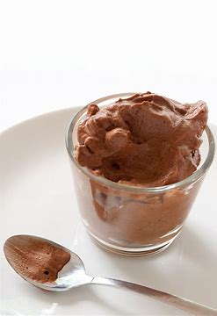

Ingredients: (makes two servings)
1 sachet instant chocolate dessert
4 tablespoons milk powder
150ml double cream 150ml whole milk
Method:
Whisk all the ingredients together with a fork or whisk until thickened.

Fortified Custard or Rice Pudding

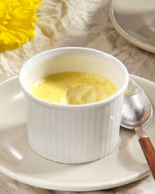
Method:
Add 1 tablespoon milk powder and 2 tablespoons double cream (30mls) to ½ can custard or rice pudding. Whisk together with a fork.
You can top the custard with your favourite fruit or have it with your favourite pie.
And why not try your rice pudding with a sprinkle of cinnamon

Better Jelly and Fruits
Method:
Add 2 tablespoons double cream, fortified custard/rice pudding, ice cream or thick and creamy yogurt to fruit and jellies.

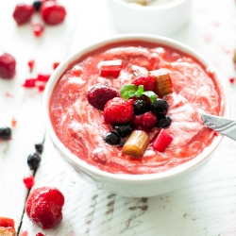

Peanut Butter and Banana Toast
Ingredients:
2 slices bread
1 medium banana, mashed
1 tablespoon peanut butter
1 tablespoon honey
Method:
Butter two slices of bread. Spread one slice with peanut butter and honey, top with mashed banana and sandwich with the other slice of bread.
You can shave some chocolate on the top if you wish.
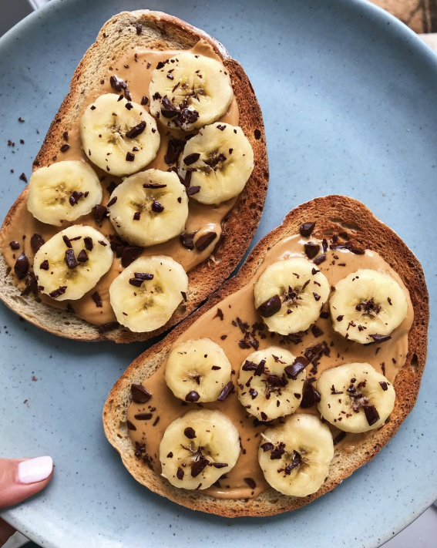

Cheesy beans on toast
Ingredients:
2 slices of bread
56g /2 ounces full fat cheddar cheese, grated or sliced
½ tin baked beans in tomato sauce
A few drops Worcester sauce to taste (optional)
Method:
Heat the beans and Worcester sauce in a pan but do not boil. Lightly toast the bread. Divide the beans between the two slices of bread, cover each slice in an ounce of cheese and place under a grill until the cheese is melted and bubbly.
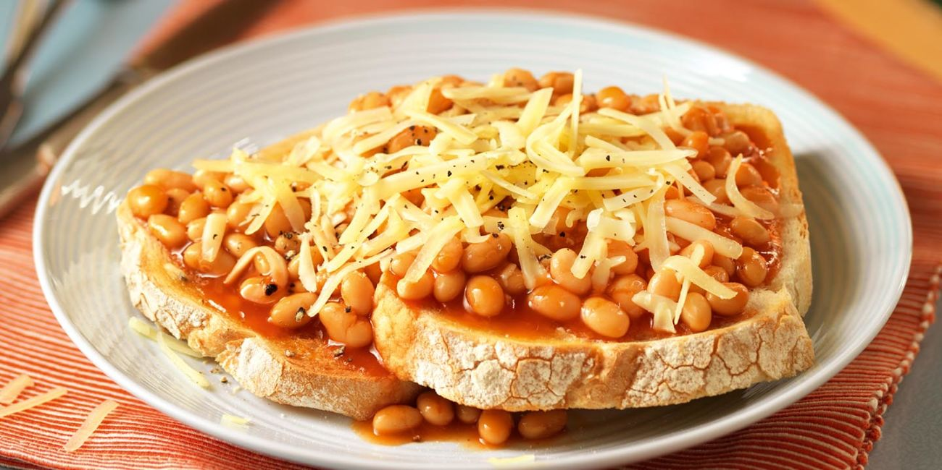

Luxury Hot Chocolate
Ingredients:
150ml full fat milk
1tablespoon milk powder
2 tablespoons double cream
3 teaspoons hot chocolate powder or malted drink powder
Method:
Mix all the ingredients together with a fork or a whisk.

Extra Creamy Milkshake

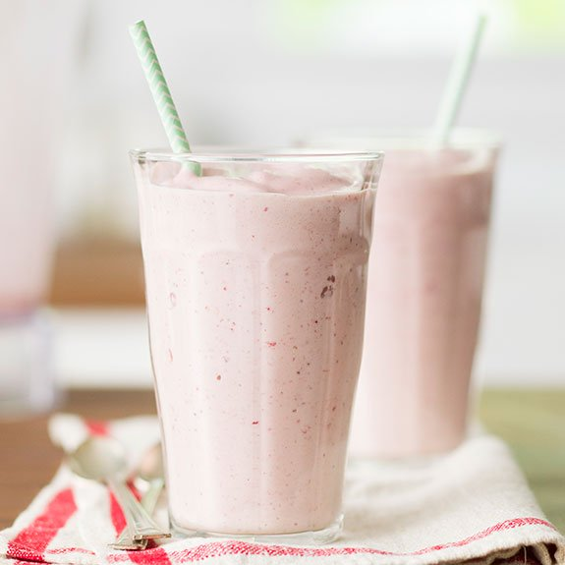
Ingredients:
4 teaspoons chocolate milkshake powder or strawberry milkshake powder (Nesquik)
2 teaspoons milk powder
200ml whole milk
1 scoop vanilla ice cream
Method:
Blend or mix together all the ingredients with about half of the milk. Then add the remaining milk and mix thoroughly with a fork or whisk until completely blended.

Refreshing Iced Coffee

Ingredients:
2 teaspoons instant coffee powder
150ml fortified milk
1 pot crème caramel
1 scoop vanilla ice cream
Ice cubes
Method:
Dissolve 2 teaspoons of instant coffee powder in 150ml fortified milk. Mix in 1 pot of crème caramel and a scoop of vanilla ice cream. Liquidise or sieve until smooth. Pour over ice.

Remember to have 6-8 drinks per day to make sure you are staying well hydrated- this will help with your ovreall health.

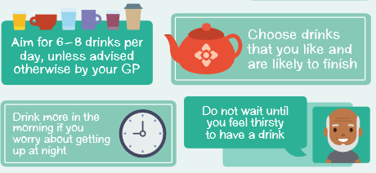

Examples of calorie and protein differece when using food fortification methods

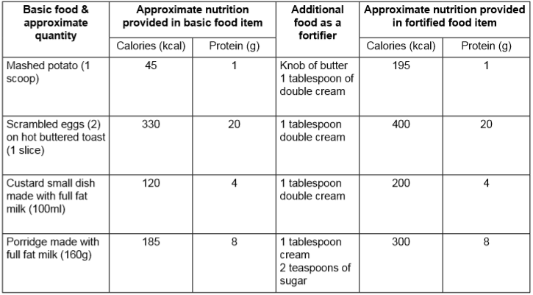
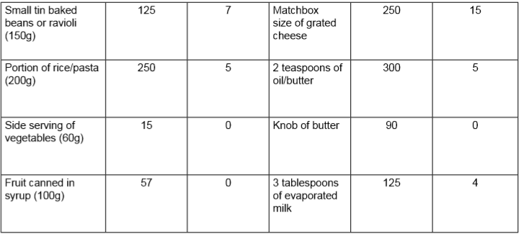

By encouraging the consumption if these snacks and nourishing drinks you can contribute to a higher daily energy and protein intake

