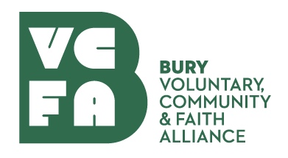
Learn about applying for emergency National Lottery Covid Funding
Here and ready to help you through COVID-19, Learn about applying for emergency National Lottery Covid Funding
About this Event
National Lottery Community Fund Support During Covid-19
Thursday 16th July 2pm till 3pm
Bury VCFA are aware that many community groups and charities are finding it difficult to manage during the past 3 months of Covid.
The National Lottery Community Fund is for now focusing on funding projects and organisations who are helping communities through the COVID-19 pandemic. Funding is being reviewed on an on-going basis and updates or developments are being shared.
This is your chance to learn about applying for emergency COVID-19 funding in England .
The government and the National Lottery have developed a joint response for distribution of government and lottery funding to support organisations to continue to deliver services to people and communities affected by COVID-19.
The event will last approximately 1 hour and will delivered through Microsoft Teams. There will be a presentation about the current criteria and priorities along with how to make an application followed by question and answer session.
Ben Autumn, NLCF Grants Officer will be delivering the presentation support by staff from Bury VCFA. If you would like to know more about the changes to priorities and criteria of the NLCF Reaching Communities and Awards of All, please book your place now.
The link to the webinar will then be sent to you approximately two days before the event.
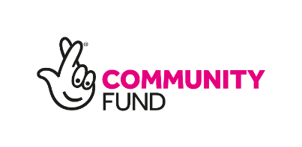
View My Event

