Bury Care Leavers Newsletter
September 2020
CORONAVIRUS UPDATE
We hope you are all keeping well and safe during the current COVID situation. Please remember that although we are not office based at the moment, we are always here for you if you need us.
You will have seen in the local news that the Coronavirus situation is a constantly changing situation. We are urging everyone to adhere to the local restrictions when in Bury and to pass the message on to others.
You must not:
- meet people you do not live with inside a private home or garden, except where you have formed a support bubble (or for other limited exemptions to be specified in law);
- visit someone else's home or garden even if they live outside of the affected areas;
- socialise with people you do not live with in other indoor public venues - such as pubs, restaurants, cafes, shops, places of worship, community centres, leisure and entertainment venues, or visitor attractions. You may attend these venues with people you live with (or are in a support bubble with), but should avoid interaction with individuals or groups from other households. If you run such a business or organise events on their premises, you should take steps to ensure people do not interact with people they do not live with, in line with COVID-19 secure guidance;
- visit friends or family in care homes, other than in exceptional circumstances. Care homes should restrict visits to these circumstances.
It is vital that we continue to abide by the local restrictions and encourage our friends and families to do the same. Equally, if you or anyone you know has symptoms of coronavirus, however mild, it is vital you are tested.
The Care Leaver Offer and Bury Directory will be kept up to date with any developments during this time.
However, we are here for you if you need to contact us, Care Leavers should contact their PA or Social Worker directly.
Please keep checking this page and links to support services being put in place across Bury, these will be updated regularly:
https://www.theburydirectory.co.uk/ for specific information relating to Care leavers, click on the “Care Leaver Offer” icon on the front page of the Directory.

OTHER NEWS:
Care Leaver Support Fund
As you know, a Fund for Care Leavers has been set up with a fund of £50,000 per year for the next two years. This fund is to be allocated to assist care leavers to get support, equipment, funding or goods that would not be available through normal Social Care Funding channels. The fund has been available since the summer and many care leavers have already accessed this. We have already allocated around £7,000 to care leavers. Items such as laptops for studies, driving lessons for employment, clothing and equipment for college have already been paid for.
Speak to your PA if you feel you have a need that could be addressed using this fund.
Constituted Group for Care Leavers
A constituted group has now been set up entitled “Friends of Bury Care Experienced Young People”. The group has been agreed and the statutory roles of the group have been allocated to its members, for example chair, treasurer. This will allow the group to bid for grants and funding not open to the Council or other statutory agencies. Any funding that we receive will be used to pay for support and activities that are currently not available to young people through statutory services. The young people themselves will decide where the money is best spent. Unfortunately we have been unable to bid for monies during the Corona Virus period as most charitable funds have been directed towards supporting people during this crisis. However, we will continue to look for funding and collect ideas from young people on what they would like to be funded. However, this does not mean the Group have not been busy, it has been agreed that the Constituted Group monitor and agree the funding from the Care Leaver Fund to ensure it is independent of Social Care and is being spent on the items that Care Leaver’s feel will be of benefit to their future.
If anyone is interested in joining the group, please let me know. We only intend to meet a couple of times a year so it will not be a massive commitment. It would be great to have care leavers as trustees on this group.
Care Leavers Offer
As you know, we have a dedicated website hosted by The Bury Directory where all care leavers from Bury can access a host of information. There is up to date information on the Corona Virus situation and support available as well as other information such as events, opportunities and information that may be useful to care leavers https://theburydirectory.co.uk/care-leavers-offer
The Bury Directory has recently been “revamped” and is in the process of being finalised. Please could all care leavers have a look at the website, tell us what you think and be honest – your feedback is really important. What is missing? What information would you like to see? What do you like about the website? Is it easy to use? There is a feedback form on the website, please let us have your comments using this link. We can only improve the website if you tell us what you want to see

Super star alert
We know you have been doing a fabulous job of keeping yourself busy and learning new skills, working hard and supporting yourself and others during the coronavirus outbreak. Here are a few examples of care leavers learning new skills. If you would like to showcase anything in the next newsletter, write an article or share something please contact Jacqui on j.waite@bury.gov.uk

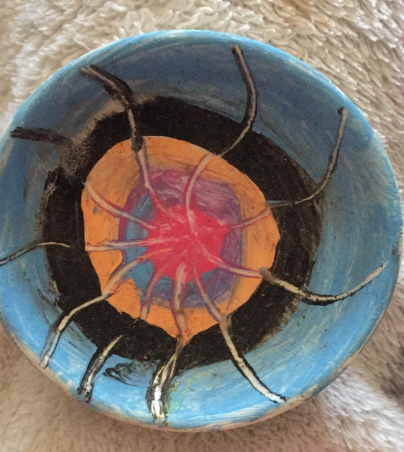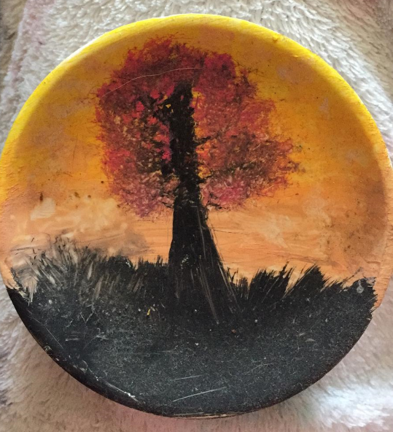
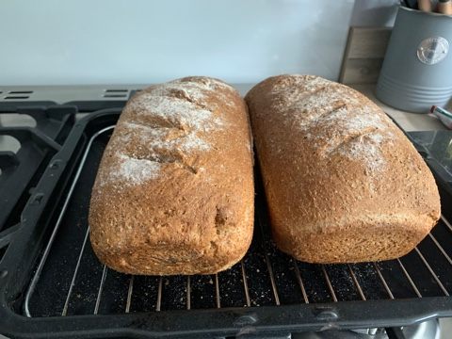

Council News
Executive Director for Children and Young People – Message from Geoff Little, Chief Exec
Karen Dolton, Executive Director for Children and Young People is due to retire at the end of this month and I’m sure you will join with me in wishing her a long and happy retirement. I would also like to thank Karen personally for her sterling work in leading the department for the last three years.
Following a rigorous interview and selection process (a Care Leaver was on the interview panel), I can confirm that Sheila Durr will take up the Executive Director post from 30 September.
Sheila brings to Bury a wealth of experience in local government management and leadership, notably at the London boroughs of Kensington and Chelsea and Hackney.
She has successfully led multi-professional teams developing effective strategies and partnerships with a focus on prevention, recovery and family and community resilience. She is proud to be a social worker who believes, from personal and professional experience, in the benefits of continuous learning for children, families and communities.
Sheila is originally from the North West and began work on the frontline of children and families social work in 1993, working for a number of authorities in the capital. She was child protection co-ordinator in Islington and at Tower Hamlets was responsible for the integration of health and social care for disabled children. She moved to Hackney where she headed up children and young people’s services across all the key areas of safeguarding, children in care and care leavers, youth services, youth offending and early help, also establishing and chairing the London Adoption Board. At Kensington and Chelsea she was director of communities and people, leading the humanitarian response to the Grenfell disaster, and has most recently been a consultant for Surrey County Council working on their SEND provision.
We look forward to extending a warm welcome to Sheila when she starts with Bury Council and the CCG in a couple of weeks’ time.
Opportunity
Please see the Care Leaver Offer for updated opportunities. However the following has recently come to our attention:
Volunteering towards Employment Project
Bury VCFA is pleased to announce our ‘Volunteering towards Employment Project’ (VtEP). VtEP aims to help participants in Bury who are unemployed or economically inactive to develop skills and confidence in a workplace environment by using volunteering to get closer to the jobs market. The European Social Fund (ESF) fund the project, which provides funding for employability and training projects.
This project offers the opportunity to develop this aspect of volunteer recruitment to help the unemployed or economically inactive to embrace volunteering as a step towards employment.
For further information and how to apply, please click here
Green Finger Project
I am very pleased to inform you that GMYN are now back to running (risk assessed, socially distanced) face to face activities! Working with the 16-25 year old group, we have set up a partnership with ‘Love Springwater Park’ and will be working every Thursday 4-530pm in the park to create a ‘Rainbow Walkway’, Sensory Garden and Scavenger Hunt for visitors to enjoy. This is a project which will run throughout the Autumn and is the perfect opportunity for new young people to join our group. You can also watch our Care Experienced Programme promo video here: https://www.youtube.com/watch?v=8tTK8ZyFIII .
Young people can learn new skills, gain experience for their CV, meet new people and generally engage in a really positive community activity. If you are interested in this, please speak to your PA to make a referral.
GMYN are still running a variety of online workshops for young people to enjoy. This includes general online workshops, employability workshops and face to face meetings in Springwater Park. Contact your PA for more information or email rachael.barber@gmyn.co.uk

Consultation:
We would like your views and ideas on the following:
- What would you really like Corporate Parenting Champions to do? What could they do to make a difference? We are to develop a mentoring and volunteering programme for champions following the lifting of coronavirus restrictions – does this sound useful and what would you find most valuable?
- We have set up a constituted group for care leavers and young people in care (see above). What’s the best way to gather ideas on what is needed by care leavers? We will use the care leaver forum and CiCC but are there other ways?
- Corporate Parents have asked for some case studies from care leavers. This would tell your story and help corporate parents realise what it like is to be in care and the ups and downs of life in care. This would be anonymised. Is anyone interested in doing this? Jacqui would write it, you’d just have to meet her for a chat and you would agree the case study before anyone read it (obviously this would take place after the current Corona Virus Outbreak)
Please contact Jacqui about the above on j.waite@bury.gov.uk
Regular events:
All face to face events have had to be postponed due to coronavirus restrictions. However, please keep in touch with your PA. The Care Leavers Forum continues to run fortnightly via Zoom. This is a fabulous group and a great chance to keep in touch with us and other care leavers. Please contact Heather Walton (h.walton@bury.gov.uk) or Jane Hayes (j.hayes@bury.gov.uk) for more information on how to log in and what happens at the Care Leavers Forums.
Regular events will recommence once the Government Guidance allows social distancing to stop. Once this happens, details of regular events will be found on the Care Leaver Offer https://theburydirectory.co.uk/care-leavers-offer

