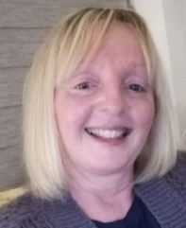 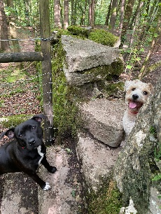

**Name:** Joanna Dunn

**Role:** Specialist Teaching Assistant, Additional Needs Team, Inclusion and Vulnerable Children Services

**PROFESSIONAL PROFILE**

**How I can help you**

As part of my job, I may come into your school to have a look at your learning environment and to have a chat with staff to help us to think about ways in which staff can work with children and young people with social communication difficulties. This might be about:

* The way they communicate and interact with you
* The way they listen to what we have to say

I might ask you some questions to help me to learn more about you e.g. what you like doing best of all in school, or dislike doing?

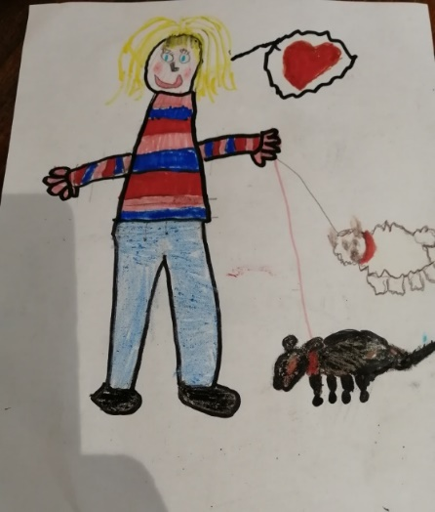

**All About me**

* I was born in Bury and have lived in Bury all my life
* I have worked for Bury LEA for the past 26 years
* I am married with two grown up children (who are also married), and one granddaughter
* I love animals, especially dogs and horses

I love going for walks in the countryside with my two dogs

* I also enjoy spending time swimming, gardening, or baking with my granddaughter
* My favourite place is the Lake District

☺

**About my role**

* I am part of the Additional Needs Team (also known as ANT)
* My role in our team is to help staff to meet the needs of children and young people in their school with social communication difficulties /Autism; also, to help schools to understand how children and young people learn, and to help them develop their social communication and interaction skills