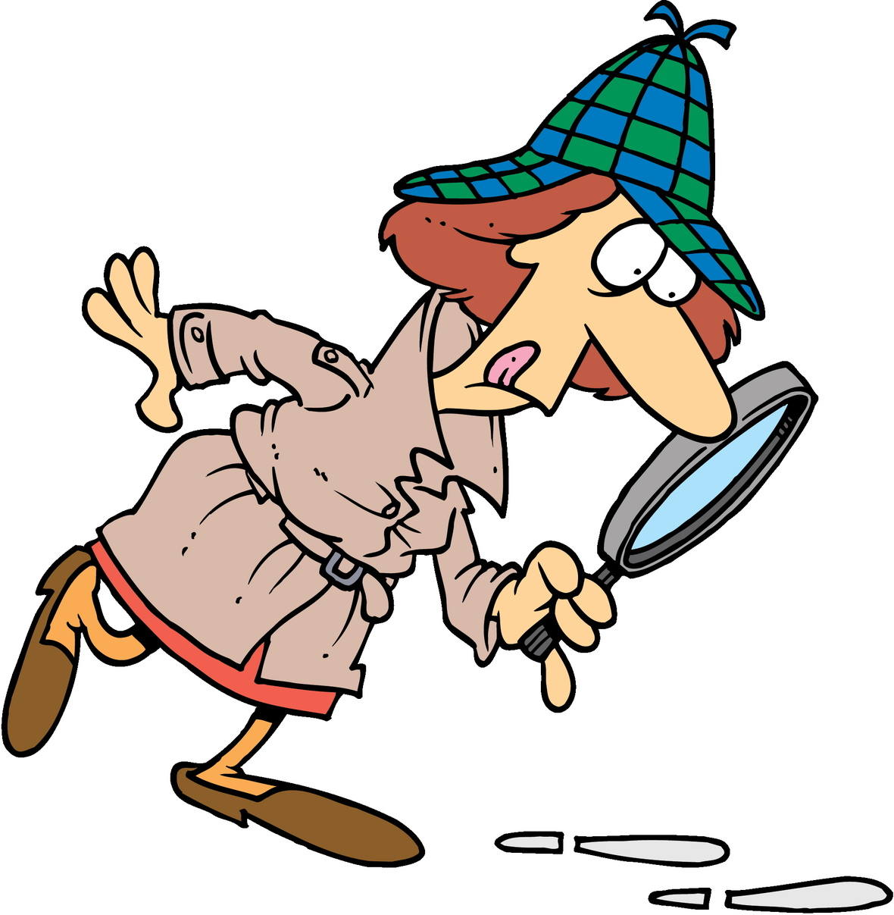 Emma Lees

The Learning Detective

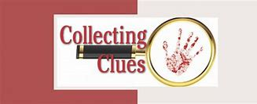I am a teacher. I work as a **learning detective**,

**My job** is to look for and collect clues about how a child/young person learns.

I collect the clues from teachers, from observing, from children and from activities.

I usually also look in schoolbooks and sometimes sit in class



***What clues can Cluedo sniff out about me?***

**I will ask :-**

What a child /young person is good at.

What they find more difficult.

How they think they learn best.

What things they like and dislike.

I have tasks activities and games which I use to help me with my detective work.

Once I have collected clues, I work with school and help develop a plan to make sure that a child has the opportunities, resources and support they need to help them learn successfully and confidently in school.

I love-

 I love…….

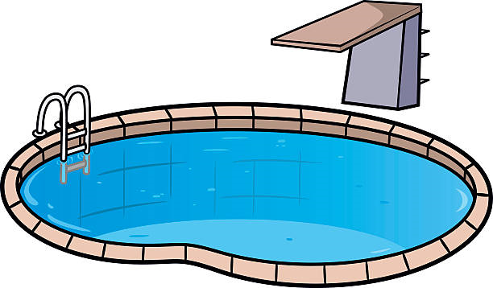 I live in a …….







I have 3 -





My husband is a I don’t like-

I’m good at-





I have a-

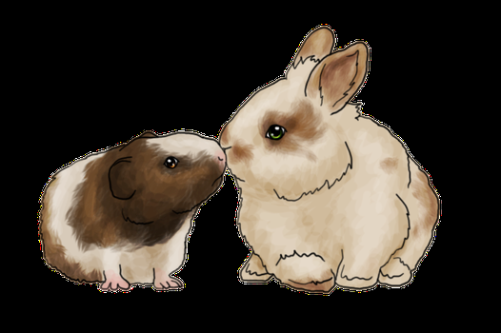



I wonder what you have

discovered about me!!