**About my role**

I oversee the Sensory Support service and work very closely with the Inclusion Service to ensure that we all work together to support Bury’s children and young people.

I provide support for the Team to ensure that our processes and systems are fit for purpose and that they help to improve the educational experience of children and young people with hearing impairments/visual impairments.

**About me**

I was born and grew up Derby and attended Derby Schools. I have lived in Derby and attended Derby schools. I have worked in a variety of roles including Teaching in a school for the Deaf, and in Special Schools during my career. I have also been a Headteacher in two Special Schools, and have worked for 4 different Local Authorities in the past 22 years.

My aim is to ensure that all children and young people with special educational needs receive the education that they are entitled to and have opportunities to develop their independence too. I have a passion for working with children and young people with special educational needs and making a positive contribution to their lives.

My hobbies out of work are spending time with my family, cycling, travelling and growing my own vegetables.

**How I can help you**

I can help families of children with hearing impairments/visual impairments to get the right help at the right time if they have any concerns or problems.

**Name:** Jenny Thompson

**Role:** Interim Sensory Team Manager

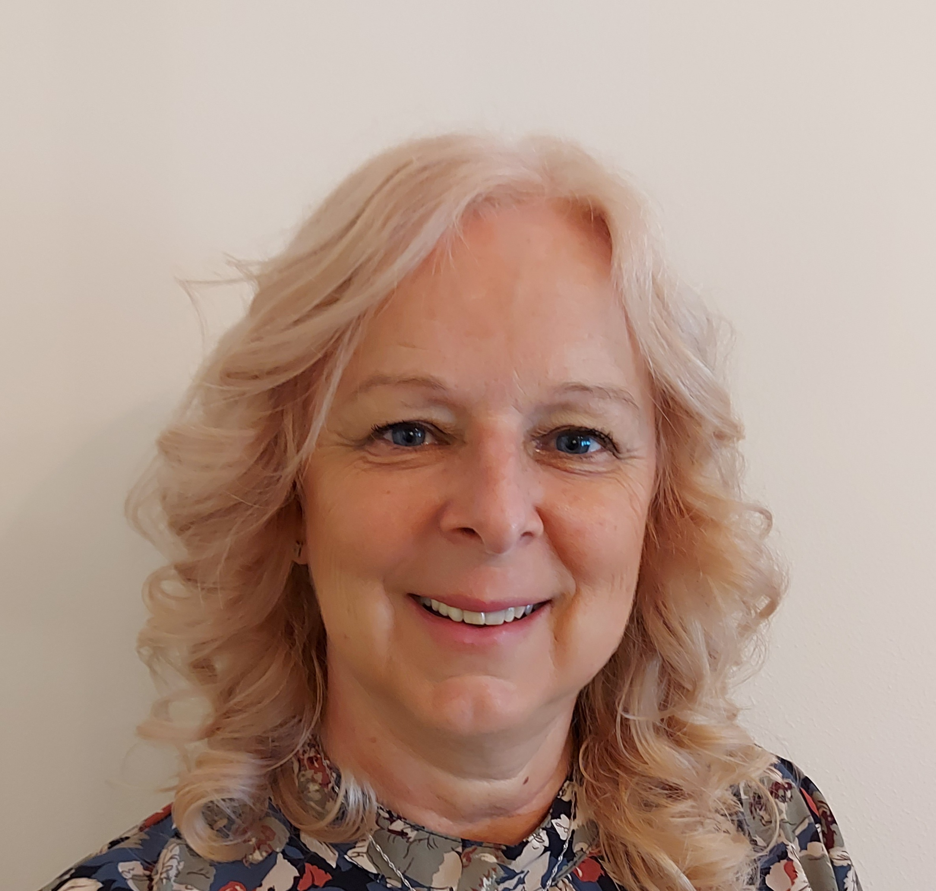

**PROFESSIONAL PROFILE**