Equality Impact Analysis
This equality impact analysis establishes the likely effects both positive and negative and potential unintended consequences that decisions, policies, projects and practices can have on people at risk of discrimination, harassment and victimisation. The analysis considers documentary evidence, data and information from stakeholder engagement/consultation to manage risk and to understand the actual or potential effect of activity, including both positive and adverse impacts, on those affected by the activity being considered.
To support completion of this analysis tool, please refer to the equality impact analysis guidance.
Section 1 – Analysis Details (Page 5 of the guidance document)
Name of Policy/Project/Decision | LETS Get Bury Moving (LGBM) – Physical Activity Strategy 2025-2028
Lead Officer (SRO or Assistant Director/Director) | Lee Buggie, Public Health Specialist, Live Well & Healthy Place
Department/Team | Bury Public Health
Proposed Implementation Date | July 2025
Author of the EqIA | Lee Buggie
Date of the EqIA

1.1 What is the main purpose of the proposed policy/project/decision and intended outcomes?
LETS Get Bury Moving | Physical Activity Strategy

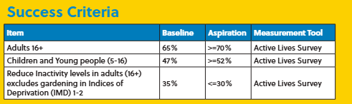

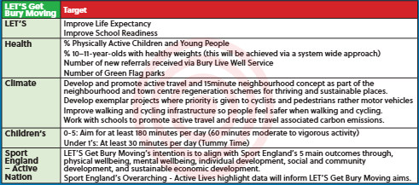

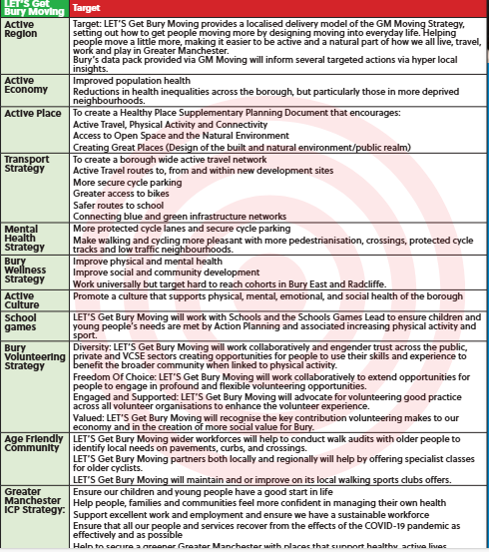
Section 2 – Impact Assessment (Pages 6 to 10 of the guidance document)

2.1 Who could the proposed policy/project/decision likely have an impact on?
Employees: Yes, Workforces are likely to be affected via the LET’S Get Buy Moving strategy and will be actively engaged

Community/Residents: Yes, the LET’S Get Bury Moving strategy focuses on communities and residents becoming active

Third parties such as suppliers, providers and voluntary organisations: Yes, third parties will be key to the delivery of the framework which enables the strategy outcomes to be achieved

If the answer to all three questions is ‘no’ there is no need to continue with this analysis.

2.2 Evidence to support the analysis. Include documentary evidence, data and stakeholder information/consultation
Documentary Evidence:
Greater Manchester Moving Strategy – Provides a regional framework for increasing physical activity and reducing inequalities: | Greater Manchester Moving
Sport England’s Uniting the Movement Strategy – Emphasizes tackling inequalities in activity levels across different population groups: Inequalities Metric | Sport England
Bury Council’s Health and Wellbeing Strategy – Aligns with the LETS Get Bury Moving goals, particularly around prevention and healthy lifestyles: Case Study: Bury Wellness Strategy - GM Active
Public Health England Guidance – On physical activity benefits and barriers for different demographic groups: https://theburydirectory.co.uk/asset-library/imported-assets/bury-health-ineqaulities-position-paper.pdf

Data:

Sport England Active Lives Survey– Localized data on physical activity levels across age, gender, disability, and socio-economic status: Active Lives | Sport England
Indices of Multiple Deprivation (IMD) – Identifies areas in Bury with the highest levels of deprivation and lowest activity levels, LGBM will take a universal approach to increased physical activity levels however a greater focus will be provided to those communities residing and becoming active in IMD 1-3: Bury (E08000002) - ONS
Office for Health Improvement and Disparities (OHID) – Local health profiles and physical inactivity prevalence: Local Health - Small Area Public Health Data | and Joint Strategic Needs Assessment | Bury Directory
Bury Council internal workforce data– To assess potential impacts on employees and identify opportunities for workplace-based interventions.
Stakeholder information/consultation: -
Community Engagement Sessions – Feedback from residents across Bury’s six townships on barriers to physical activity, informally completed with Bury Blind Society, Growing Together Radcliffe and children & young people via Greater Manchester Place work : Bury Local Pilot Governance and Plan Brief March 2019 FINAL
Workshops with Voluntary and Community Sector (VCS) Partners – Insights into how to co-deliver inclusive and accessible activities, LGBM will utilise feedback from Bury VCFA Leadership group; Bury VCSE Leadership Group – Bury VCFA
Consultation with Disability Advocacy Groups – To ensure inclusive design and delivery of physical activity opportunities. Feedback included:
Feedback from Youth and Older People’s Forums – Highlighted age-specific needs and preferences for activity types and settings. Bury Local Pilot Governance and Plan Brief March 2019 FINAL
Internal Council Staff Survey – Gathered views on workplace wellbeing and opportunities for physical activity.

2.3 Consider the following questions in terms of who the policy/project/decision could potentially have an impact on. Detail these in the impact assessment table (2.4) and the potential impact this could have.
- Could the proposal prevent the promotion of equality of opportunity or good relations between different equality groups?
- Could the proposal create barriers to accessing a service or obtaining employment because of a protected characteristic?
- Could the proposal affect the usage or experience of a service because of a protected characteristic?
- Could a protected characteristic be disproportionately advantaged or disadvantaged by the proposal?
- Could the proposal make it more or less likely that a protected characteristic will be at risk of harassment or victimisation?
- Could the proposal affect public attitudes towards a protected characteristic (e.g. by increasing or reducing their presence in the community)?
- Could the proposal prevent or limit a protected characteristic contributing to the democratic running of the council?

2.4 Characteristic | Potential Impacts | Evidence (from 2.2) to demonstrate this impact | Mitigations to reduce negative impact | Impact level with mitigations  Positive, Neutral, Negative
Age | Increased physical activity across all age groups | Age-specific programming and monitoring via GM Moving data Active Lives Survey; GM Moving Strategy; stakeholder feedback from youth and older people’s forums | Feedback included activating more schools and this will be achieved through an Active School Accreditation. Using technology such as Tik Tok and Instagram to reach specific audiences | Positive
Disability | Risk of exclusion if activities are not accessible | Consultation with disability groups; Sport England guidance | Inclusion checks; co-design with disability advocates; accessible venues. Walk and Wheeling audits completed in Moorside. Visually Impaired specific equipment (Showdown) match funded with GM Place pilot. Provision such as more benches, walking audits, cycling provision, inclusive walks in parks and new specialist equipment. Consultation with Bury Leisure provided insights into inclusive activity and plans for the newly proposed Bury West Hub. | Neutral to Positive
Gender Reassignment | Potential for exclusion if environments are not inclusive | Moving to Inclusion Toolkit: Moving to Inclusion - Equality, Diversity and Inclusion Hub | Use of inclusive language and facilities; staff training. Engage with local LGBTQ+ focus groups. Co-design programmes with trans and non-binary residents to ensure their needs and preferences are reflected. Ensure changing rooms, toilets, and signage are inclusive and offer privacy. Consider gender-neutral options where possible. Promote inclusive programmes during key awareness dates e.g. Trans Day, Pride Month. | Neutral to Positive
Marriage and Civil Partnership | No specific impact identified | N/A | Couples based programmes which offer fitness classes, walking groups or dance sessions designed for pairs, this could enhance motivation and accountability. Flexible scheduling with Leisure around providing early morning, lunchtime and evening sessions which accommodate work and family commitments. On- site childcare has previously been explored but could be revisited at newly proposed Radcliffe Hub. | Neutral to Positive
Pregnancy and Maternity | Opportunity to support physical activity during pregnancy | Public Health England guidance and chief medical officer recommendations | Tailored programmes for pregnant women and collaboration with maternity services | Positive
Race | Risk of underrepresentation in participation | Active Lives ethnicity data and community engagement, suggestions include Community led programmes, Targeted outreach, culturally relevant activities, training and representation, Accessible spaces plus data and evaluation. | Targeted outreach and culturally appropriate activities such as: Women-only swimming sessions in culturally sensitive environments. Develop tailored messaging in multiple languages and formats. Offer family-friendly formats to encourage intergenerational participation. Work with planning teams to ensure safe, welcoming environments in parks and leisure centres. Share success stories and challenges to build momentum and accountability. | Neutral to Positive
Religion and Belief | Potential scheduling or venue conflicts with religious practices | Community consultation | Flexible scheduling; use of community venues. | Neutral
Sex | Women’s safety concerns in public spaces | Community feedback and national research | Improved lighting and design of public spaces plus women-only sessions. Consider timing for women, women are more likely to be carers and single mothers so activities need to be timed so they can manage caring responsibilities, school runs, childcare and work. | Neutral to Positive
Sexual Orientation | Risk of exclusion if environments are not inclusive | Stakeholder feedback | Inclusive messaging; staff training. Replicate approaches outlined in Gender Reassignment. | Neutral
Carers | Time constraints may limit participation | Community engagement | Flexible and short-duration sessions; carer-inclusive activities. Promotion of i.e., walks/walk and wheel sessions. Carers UK Carers Active Hub offer a series of 15-minute videos designed for all abilities; these include: seated exercise, Dance, Pilates, mindful movement and functional fitness. Carers UK produce videos to support unpaid carers to be more physically active from home | Carers First | Neutral to Positive
Looked After Children and Care Leavers | May face barriers to participation due to instability or lack of support | Local authority data | Youth engagement Partner with youth services; provide free or subsidised access. Work with Bury Virtual School, youth services, and Live Well Bury to map and promote opportunities. Offer activity vouchers or transport support for care leavers. Develop nature-based activities (e.g., walking groups, gardening) in Bury’s Green Flag parks. | Neutral to Positive
Socio-economically vulnerable | Less likely to be active due to cost, access, or awareness | IMD data; Active Lives Survey. Interventions to improve physical activity among socioeconomically disadvantaged groups: an umbrella review | International Journal of Behavioral Nutrition and Physical Activity | Full Text | Free/low-cost activities in IMD 1–2 areas; community outreach. Map areas of low activity and high deprivation using local data. Partner with Live Well Bury, VCSE groups, and community champions. Co-design programs with residents to ensure relevance and ownership. | Positive
Veterans | May benefit from structured physical activity for wellbeing Local veterans’ support groups | Partner with veteran’s organisations | Partner with veteran’s organisations; promote inclusive opportunities. Train local health and leisure staff on veteran-specific needs. Include veterans in Live Well Bury campaigns and referral pathways. Use social prescribing to connect veterans with physical activity opportunities | Positive

Actions required to mitigate/reduce/eliminate negative impacts or to complete the analysis
2.5 Characteristics | Action | Action Owner | Completion Date
Disability  Sex  Socio-economically vulnerable  Carers  Race / Religion and Belief  Gender Reassignment /Sexual Orientation  Pregnancy and Maternity  Looked After Children and Care Leavers  Veterans | Conduct regular inclusion audits with providers and co-design activities with disabled users.  Improve lighting and design of public spaces to enhance safety for women.  Deliver free/low-cost physical activity sessions in IMD 1–2 areas, partner with Live Well and VCFA as ongoing.  Develop flexible, short-duration sessions and promote carer-inclusive activities, meet with Bury Carers Hub.  Ensure cultural sensitivity in programme design and offer flexible scheduling  Provide staff training on inclusive practices and language use  Partner with maternity services to offer tailored physical activity programmes  Collaborate with youth services to provide accessible opportunities  Partner with veterans’ organisations to promote inclusive and structured activities | Public Health Team / VCS Partners  Bury Council Planning & Infrastructure  Public Health Team / Community Providers  Public Health Team  Community Engagement Team  HR / EDI Team  Public Health Team / NHS Maternity Services  Children’s Services / Youth Engagement  Public Health Team / Veterans’ Liaison | Ongoing from July 2025  March 2026  Start July 2025, review quarterly  September 2025  December 2025  November 2025  October 2025  August 2025  October 2025

3.1 Identifying risk level (Pages 10 - 12 of the guidance document)
Impact x Likelihood = Score |  |  | Likelihood
 |  |  | 1 | 2 | 3 | 4
 |  |  | Unlikely | Possible | Likely | Very likely
Impact | 4 | Very High | 4 | 8 | 12 | 16
 | 3 | High | 3 | 6 | 9 | 12
 | 2 | Medium | 2 | 4 | 6 | 8
 | 1 | Low | 1 | 2 | 3 | 4
 | 0 | Positive /  No impact | 0 | 0 | 0 | 0

Risk Level | No Risk = 0 | Low Risk = 1 - 4 | Medium Risk = 5 – 7 | High Risk = 8 - 16

3.2 Level of risk identified | Low Risk
3.3 Reasons for risk level calculation | The LET’S Get Bury Moving strategy has been designed with a strong emphasis on inclusion and equity. While some potential barriers were identified (e.g., accessibility for disabled individuals, cultural considerations, and affordability), these have been addressed through targeted mitigations such as co-design with affected groups, flexible programming, and free/low-cost options. The likelihood of negative impacts is low due to proactive planning and stakeholder engagement, and the overall impact is positive across most protected characteristics.

Section 4 - Analysis Decision (Page 11 of the guidance document)
4.1 Analysis Decision | X | Reasons for This Decision
There is no negative impact therefore the activity will proceed
There are low impacts or risks identified which can be mitigated or managed to reduce the risks and activity will proceed | X | The LETS Get Bury Moving strategy has been developed using robust evidence, inclusive consultation, and a clear framework for monitoring and adaptation. Identified risks are manageable and have corresponding actions in place. The initiative aligns with broader public health and equality objectives and is expected to have a net positive impact on health and wellbeing across Bury’s diverse communities.
There are medium to high risks identified which cannot be mitigated following careful and thorough consideration. The activity will proceed with caution and this risk recorded on the risk register, ensuring continual review

Section 5 – Sign Off and Revisions (Page 11 of the guidance document)
5.1 Sign Off | Name | Date | Comments
Lead Officer/SRO/Project Manager | Lee Buggie | June 2025
Responsible Asst. Director/Director | Jon Hobday | June 2025
EDI

EqIA Revision Log
5.2 Revision Date | Revision By | Revision Details
November 2025 | Stefan Taylor | Quarterly Updates 2025-2028

