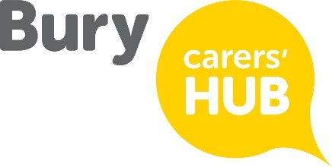
Connect 5 –Carers Mental Wellbeing Training
13th March 1-2:30 Venue to be confirmed.
To book a place, please email jayne.harrison@burycarershub.org.uk, send a Facebook message or call 0300 303 0207. Numbers are limited.
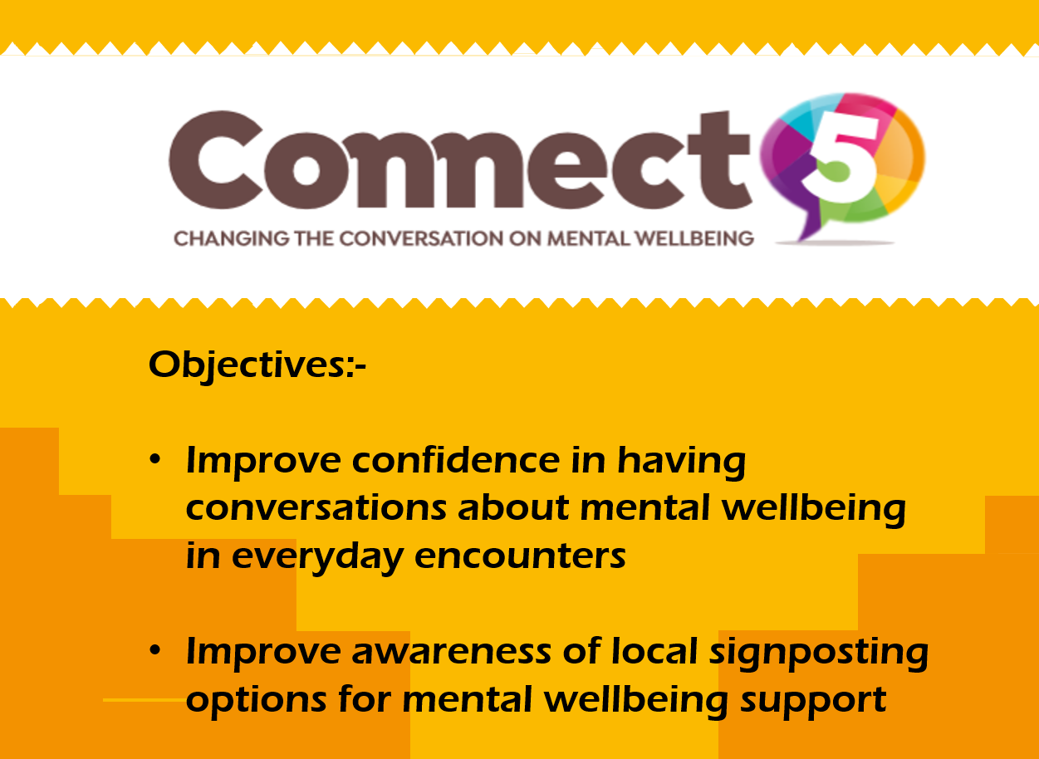
Hi, I’m Neil the Connect 5 Trainer for n-compass! I have a real passion for helping others and have lots of experience of supporting people with their mental wellbeing. Connect 5 is an educational input designed to improve confidence in engaging in conversations about mental wellbeing. All courses are free, there is no pressure on anybody to share anything and there are no role-plays. I aim to make all sessions engaging, useful and enjoyable.

Recent training feedback:-
- This training also allowed me to reflect on my own wellbeing and ideas to help me in the future. A great session well presented with care and consideration, well worth the time to attend
- Neil delivered some very interesting content and made the subject very relatable and enjoyable.

