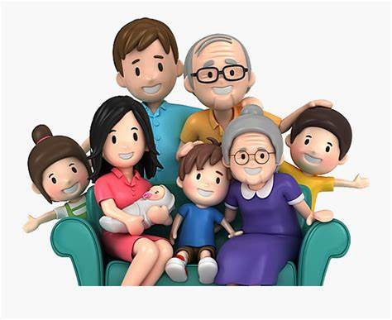

Helen