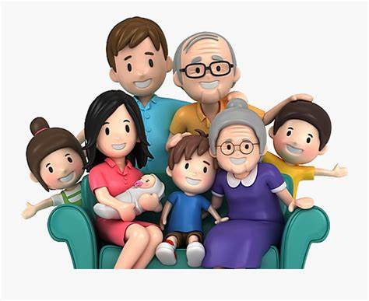



Naila