Parent/ Carers Information Pack
We offer specialist services to children and young people who are experiencing mental health difficulties. Our Service support young people and their families up to 18 years, up to 19 for neurodevelopmental conditions.

We are part of the wider support systems available in this area for Children Young people and their family / carers who are having difficulty with emotional and or mental health issues, we work closely with colleagues in other services such as the Community Eating Disorder Service (CEDS), Home Treatment Team, Rapid Response Team as well as colleagues in Education, Voluntary Sector, Social Care and the Early Help and Assessment Team.
All services in Greater Manchester working with children and young people work towards a model called the ‘i-Thrive model’ which you can see below. The following link is useful in explaining the model also: THRIVE Framework for system change (Wolpert et al., 2019) Animation - YouTube.
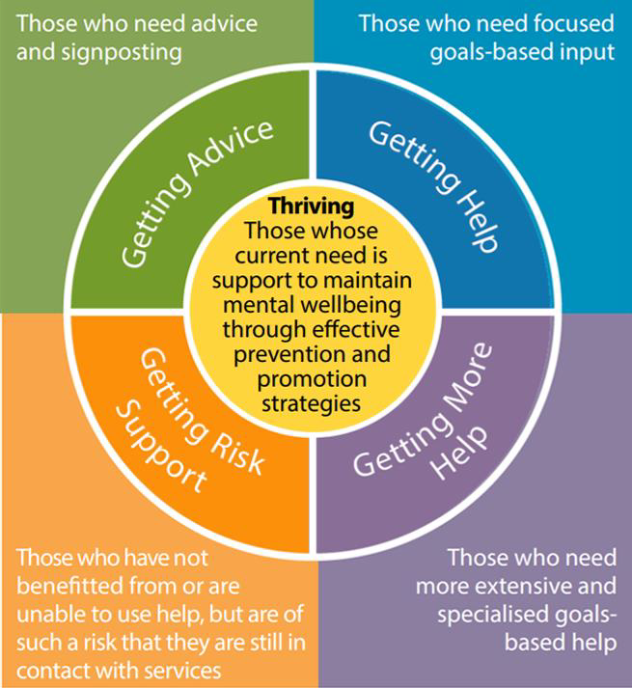

The aim of the iThrive model is to ensure that children and Young people receive the Right support for their needs at the right time when it is needed.
This is different to how services have been set up in the past as they have previously been more tiered which was not felt to be as effective or responsive to the level of need at the time.

Why do children and young people come to CAMHS?
One in six children aged 5 to 16 were identified as having a problem with emotional and /or mental health issues in July 2021. The pandemic has been found to be a significant contributing factor behind this however, there are many different reasons why children, young people and their parents/carers might come to CAMHS. Children/ Young People and their parents/carers might come to CAMHS if they are feeling sad, worried, or angry a lot of the time. It is important to remember that sadness, anger and worry are normal feelings that we all experience at different times for different reasons, but when someone experiences too much of one or more of these feelings, it can start to affect relationships, home and school life and leisure activities. Sometimes you may notice this and ask for support. Sometimes someone who spends a lot of time with you may notice and request that you get support with it.
Children and young people go through lots of changes; physically, emotionally, and socially, for a lot of us this can be a very stressful experience. Some people may find it more difficult to cope with the stress and may need support. It may be that support has been accessed from another service, but it has been agreed that it would be helpful for CAMHS to offer an assessment.
The services offered by CAMHS may be offered in a variety of settings and professionals this is depending on who is working with the child / Young person and may be offered by our partner agencies either from the Voluntary Sector or within school setting by Education Mental Health Practitioners (EMHP). Whoever is working with your son / daughter they will have the required skills to meet the need of the person they are working with.

What to expect when you visit CAMHS
Your first appointment
When you come to see us, you’ll first check in with our reception team. They’ll let your clinician know you’re here. Your clinician will come out to meet you and introduce themselves. Your Son / Daughter will be given the choice to meet one-to-one or, if they feel more comfortable, you (parent/ guardian) can also be part of this discussion. If at this point you Son / Daughter is seen alone you will be invited into the discussion at some point during the assessment and may be seen alone to take history
Who will I meet at the appointment?
You’ll meet one of our experienced practitioners. We have lots of different professionals within our team and we’ll do our best to match you to someone with the skills to help you. At times, we have students or people studying who spend time with us, as part of their training they may need to observe appointments. We will always ask if it’s ok for someone to come into your appointment.
What will happen at the appointment?
It’s really important for us to try and understand how things are for you right now. This does mean that we sometimes ask a lot of questions; this helps us understand your world. Sometimes we may ask to do your blood pressure, height and/ or weight but we will always talk to you about whether this is necessary.
What will happen afterwards?
An important part of the first appointment will be to think and talk about what happens next. Sometimes we will need to arrange to meet again and, at other times, we may feel another service is better to work with you at this time. We will always discuss plans next steps and agree with you before doing anything. We will also write to your GP and the person who referred you summarising our appointment and the plans moving forwards.

For more information, please see our website www.penninecare.nhs.uk/hmrcamhs
www.thismayhelp.me is also a useful source of information.

Frequently asked questions
What types of support do CAMHS offer?
Ongoing support offered from CAMHS, which we often call Partnership Work this is because we aim to work in partnership with you as a whole family. These appointments focus on reaching the goals identified in the Choice (1st) appointment. This is where we agreed what issues we are working we are work towards improving or understanding better. A variety of different interventions and therapies may be offered including, cognitive behavioural therapy (CBT), family therapy or medication. If medication is advised, this would be managed by one of our Psychiatrists and the reason for this and the side effects will be explained to you and your child fully. It is important to remember the type of therapy offered will be different for each individual and will be based on their own individual needs.
What are goals and why do we set them?
At the Choice (1st) appointment you and your child will be asked to identify individual and family goals to work on in order to be able to manage the situation better. Sometimes the individual and family goals are very similar, but it may be that your child has different ideas to yourself about what is important for them to work on with CAMHS.
Goals are set at the beginning of working together to make sure the sessions focus on what is important to you and your child. The goals set should be specific, measurable, achievable, realistic, and time-specific (also known as SMART goals). This will help everyone involved to know when the goals have been met. We use questionnaires and scaling questions regularly throughout our work to make sure what we are doing is making a difference. We call these questionnaires- Routine Outcome Measures (ROMS).

Will I attend every session?
Some children or young people who come to CAMHS will have appointments on their own; others will have meetings with their parent/ carer. Some will have a combination of both. We appreciate that it can be difficult for some parents/carers to regularly attend appointments, in these instances it is useful to talk to your child’s worker to establish the best way to communicate and share any information or worries/ concerns.
If it is not possible or young people feel that they do not wish for parents/carers to attend every appointment- A plan will then be agreed about how a child or young person is supported if they have attended an appointment alone and are distressed. Parents/carers may be contacted in these instances to ensure a plan is in place to provide support for the child or young person after their appointment. We may also contact you if we do not feel they are safe.
What if my child doesn’t want to attend the appointment?
Many children and young people can feel nervous about coming to an appointment, we hope that having some information about what to expect can help people to feel better about this. If your child does not think it would be helpful, have a discussion with them about what they feel would be helpful for them.
If your child does not want to attend but you feel it is necessary that they attend their appointment, please do contact us and discuss how we can move forwards together. We do have the option of doing a video assessment. If you are not able to attend the appointment, please do let us know as soon as possible.

Will my child see the same person every time?
You will see one member of staff for your first (Choice) appointment. If further (Partnership) work is agreed, this will often be with a different member of staff to ensure you are seen by the right person with the training and skills to meet your needs. Building a trusting relationship is fundamental to much of the work that we do so consistency is really important to us.
Where possible we like your child to see the same person during ongoing work and appointments, however there are times when this may not be possible. Sometimes your child may think that progress is not being made working together and that a change of worker might be helpful. Sometimes your child might make this decision alone and sometimes our staff change role or move on.
We recognise that it can take a lot to develop an effective therapeutic relationship and so consistency of worker is really important however if you feel that a change is necessary, it is worth discussing with your worker first.
What information will be shared with me?
You are really important in your child’s life and ultimately responsible for keeping your child safe and making some decisions on their behalf (hopefully with their agreement too). You might be invited to review sessions, receive regular telephone contact or more formal family work. We will not usually tell parents/ carers everything that has been discussed in therapy, but we will share important information or themes from the work so that you can support your child.
In NHS services young people over the age of 16years old are classed as being adults and by law they have the right to consent to who information is shared with including parents/ carers.

Who do CAMHS work with or speak to?
We may speak with/share reports with your child’s GP, social care, school, the child development centre, and others depending on who it is important to share information with. We usually speak with you and your child first before sharing information with any of the above services/people but may have to do so without your permission if we think you or your child is unsafe. Generally, we need to keep your child’s GP informed of their care as they usually become responsible for their care once they are discharged from CAMHS, so it is important they are aware of support received.
Support before and between appointments
A lot of children and young people come to CAMHS, which means that sometimes there is a waiting list for an appointment. Whilst waiting, you may need support. There are a number of tools online and details of local support contacts on our CAMHS webpage www.penninecare.nhs.uk/camhs.

Our single point of Access Teams are always on hand to offer advice and guidance prior to coming to an appointment, they can be contacted on- (needs to be specific to each Borough). A full list of local organisations and services and their contact details can also be found at the end of this information pack.
Non-emergency support At CAMHS:
We have a duty system within all CAMHS services whereby if you need to speak to someone outside of session times and your care coordinator is not available, the duty team are available from 9am until 5pm from Monday to Friday.
For out-of-hours advice you can contact the Mental Health helpline on 0800 0149995. This line is staffed by qualified clinicians in the NHS for support 24/7, including bank holidays. Finally for more support as a parent or carer, please see the back of this booklet for more helpful websites and contacts.

Emergency support
In an emergency, when you are unable to keep yourself, your child or your family safe, please call 999 or make use of your local A&E service.
What can I do if I am unhappy with the service?
You can speak to your child’s therapist if you are unhappy with their treatment at CAMHS. If this is not possible, then you can speak to the CAMHS manager. If still unresolved, you can contact PALS (Patient Advice and Liaison Service) who can help you to find out what is happening with your child’s care. They can also support you to get a resolution to any challenges you are facing with the service or process a complaint if necessary.

They can be contacted on: Patient Advice and Liaison Services (PALS)
Pennine Care NHS Foundation Trust
Trust Headquarters
225 Old Street
Ashton-under-Lyne
Lancashire
OL6 7SR
Tel: 0161 716 3178 (24-hour answer phone) Email Contact: pals.penninecare@nhs.net

