

Audit to assess the

quality of Out of School Club provision

by Bury Early Years Advisory Team

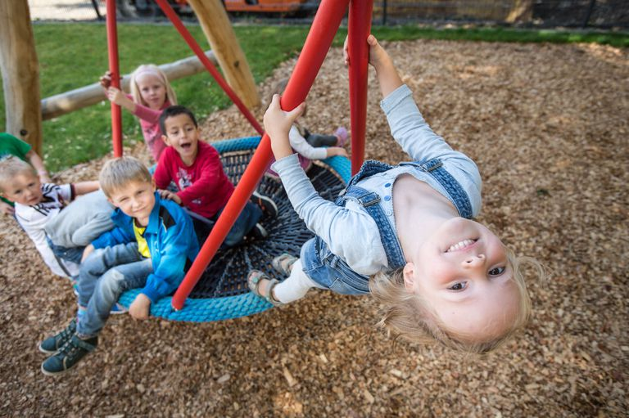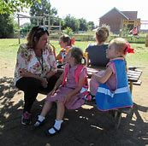

**Name of setting:**

**Out of school club Quality Audit**

|  |  |  |  |
| --- | --- | --- | --- |
| **Inspector comments taken from Ofsted inspections of Out of school provision** | **Do you demonstrate this in your club?** | **If so how? What documents, procedures demonstrate/evidence this?** | **Actions: What do I need to do to improve?** |
| All staff have a clear understanding of Safeguarding and this is demonstrated  through training and all staff having an awareness of what to do in the event of  a disclosure/allegation against a staff member. |  |  |  |
| All staff have a sound knowledge of the Prevent Duty and strategy and local procedures, and how to promote British values effectively. |  |  |  |
| All staff have a sound knowledge of FGM and duties in relation to this |  |  |  |
| Children feel safe at the club and are able to share their concerns or worries with staff, knowing they will be listened to and supported |  |  |  |
| Snack time has a real family atmosphere as children and staff alike laugh and have fun with each other. |  |  |  |
| Staff ensure that children have access to fresh drinking water at all times and are provided with healthy and nutritious meals on a daily basis. For example, children eat fresh cucumber, tomatoes, peppers and carrots, alongside a range of fresh fruit. |  |  |  |
| Managers meet regularly with staff, support their well-being and establish any training and development requirements. |  |  |  |
| Staff team are committed to attending ongoing training and share this knowledge with other members of the team through regular staff meetings. |  |  |  |
| Peer observations and supervisions also inform training and practice and impact is evaluated from this. Supervisions are also used to support staff to reflect and focus how to enhance the provision for the youngest children who attend. |  |  |  |
| Robust risk assessments are meticulously maintained. |  |  |  |
| Superb organisation, planning and communication between all ensures that roles and responsibilities are clearly defined which contributes to the smooth running of the setting. |  |  |  |
| All records, documents, policies and procedures are meticulously maintained and stored/updated regularly, which ensures they reflect current information. |  |  |  |
| An extensive self-evaluation system is in place and there is total commitment.  The staff team are forward thinking and constantly reflect on their practice and identify were improvements can be made. An open sense of communication is fostered by all and seen as a positive approach. |  |  |  |
| The staff demonstrate an exemplary attitude to making the provision inclusive. |  |  |  |
| There are planned, purposeful play and exploration experiences on offer for the children, with a balance of adult led and child led activities. |  |  |  |
| Opportunities for to make choices in their activities are abundant including eating and socialising. |  |  |  |
| Plans and activities are systematically evaluated and next steps are noted by  each child's key person. |  |  |  |
| Highly successful strategies are in place to involve parents in the two way sharing of info in particular for EY children. |  |  |  |
| Parents are consulted and involved in focusing how the club can be improved. |  |  |  |
| Liaison with other agencies/school is well established in relation to Early Years children and their progress. |  |  |  |
| Staff have excellent knowledge of the Early Years Foundation Stage and are extremely effective in planning exciting and imaginative activities for the  Children. |  |  |  |
| EYFS children’s experiences are evident as there are colourful photographs displayed and examples of art and craft work. |  |  |  |
| Praise and encouragement is extensively used and processes are in place to reward kind or good behaviour. |  |  |  |
| Staff are effectively deployed with each member taking on specific roles and tasks each day therefore children’s individual needs and requests for support with specific activities can be consistently met. |  |  |  |
| The club manager meets with parents and children who are new to the school at the start of each academic year. This ensures that she is familiar to them and helps children know what to expect from the club. |  |  |  |
| Children have good knowledge of all the safety precautions in the club. Children carry out effective risk assessments of both the indoor and outdoor environments, which promote problem solving and thinking skills, as they identify a hazard and consider what needs to be done to make it safe. |  |  |  |
| The setting gives children frequent opportunities to voice and express their physical skills and enjoy being in the fresh air. |  |  |  |
| Staff find out all about children's interests before they start. This helps to ensure that young children's social and emotional needs are well attended and encourages them settle quickly. |  |  |  |
| Fundamental British values are promoted by giving opportunities for children to contribute to the planning of activities and organising the environment. Children are encouraged to vote for their favourite ideas via a show of hands or other methods.  For those children who cannot express their ideas, observation of the child’s of play should be valued and used to identify their thoughts. |  |  |  |
| Children have free access to activities as the deployment of resources enables them to make their own decisions about how they spend their time. |  |  |  |
| Parents express that their children's confidence has soared since attending |  |  |  |
| The staff use a sensitive, positive and consistent approach to managing  behaviour, which takes into account children’s understanding and maturity. Children therefore learn to distinguish right from wrong and begin to develop moral awareness. |  |  |  |
| Staff collaborate with children to create rules and codes of behaviour. Children agree specific rules for things such as tidying up, which helps them to understand that rules apply to everyone. |  |  |  |
| Children are supported to respect others views, cultures, and races. They are supported by staff to challenge stereotypical behaviour. |  |  |  |
| Resources and premises are kept clean and regular systems are in place to ensure this is consistent. |  |  |  |
| Older children are given opportunities to buddy up and support younger children or children that are new to the club. |  |  |  |
| Children are offered opportunities to serve and prepare snacks, and help set up activities and recourses whenever possible. This supports their independence. |  |  |  |
| The environment includes an area with soft furnishings/resources so that children can rest/ relax or just take some quiet time slightly away from the rest of the group. |  |  |  |