Swans Care and Education

Address: 42 Whittaker Lane
Prestwich
Manchester
M25 1FX
Contact Number: 01617988877
Email: cyg2swans@btconnect.com

Introduction
As you read through the booklet you will learn about our nursery, the love, care, guidance and endless amounts of fun that we have each and every day.
We ensure that we achieve the following:
- We pride ourselves in reaching all our early year goals with each and every one of our children and help them to grow and learn in a safe and happy environment.
- We regard each child as an individual, and to encourage and nurture them in to developing their own character and personality.
- We have an on-going commitment to work closely with you as a parent to ensure that all of your needs and requirements are met.
We represent our commitment to you on our motto “In Partnership with Parents” as we believe that we will give your child the level of care that you, as a parent, would give.
Should you require any further help or information please do not hesitate to contact us
At Swans care and Education we pride ourselves in working with you to bring your most precious child through each learning curve to give them the best start in life.
We hope that you have enjoyed this small insight in to our nursery, but we do feel that you need to come along and see us to be able to fully understand our commitment and support that we feel we can give to your child.

Partnership with Parents
We believe it is vital to work with you and you know your child better than anyone. We also want you to feel at home and feel it’s your nursery, and to know what happens each day. We have parent information notice boards in the entrance to keep you up to date on nursery happenings. We produce a newsletter every 2 months to let you know what the children have been doing. Your child will also obtain a daily diary with all daily activities and information in regards to your child’s day at Nursery which will now be accessible online

Opening Times:
We are open from 7:30am – 6:00pm, Monday to Friday
Half days are 7:30am – 12:30pm and 1:00pm – 6:00pm
We are closed on bank holidays.

Payments
You will be required to fill out a contract before your child starts nursery.
The fees are as follows: Full time place: £165.00
Full day: £40.00
Half day: £25.50
All fees are payable on a weekly/monthly basis, at the beginning of each week/month. We provide full receipts for all payments made and are happy to help in giving guidance and information in any payment awards that your child may be entitled to from the government.
Ofsted
We provide care for children from the age of birth to five years.
We are Ofsted registered, the registration number is – EY482453
We are subject to an inspection any time without prior to notice.
Our Staff
We have fully qualified nursery practitioners on site at all times which are also all qualified in First Aid, Safeguarding and Food Hygiene.
We also allow local students, who are in training, to carry out placements in our nursery.
Please note that all staff are subject to a full DBS check before being allowed to care for our children.
Early Years Foundation Stage
We offer facilities that will help children reach the early learning goals throughout the foundation stage. All our planning for activities and play takes full account of the EYFS curriculum. Each child’s ability is taken into account when planning and carrying out any activities, to ensure each child’s individual needs are met.
Each child is appointed a keyworker, who is responsible for the introduction and monitoring the child’s development. Observational and photographic recording and monitoring is used to evaluate the child’s development.
Online Learning Journals
We have recently changed the way we document children’s learning journals, changing from paper copies to Online Journals. This means the staff are able to add observations in a fraction of the time and are able to spend much more quality time with the children. With the Online Journals it means that parents/carers are able to access the accounts at home and see their child’s development and also contribute and comment to observations that have been documented.

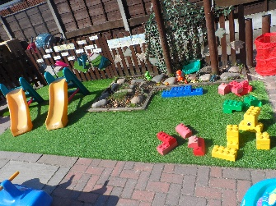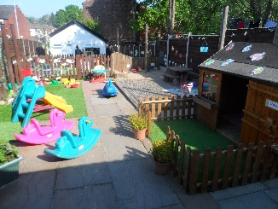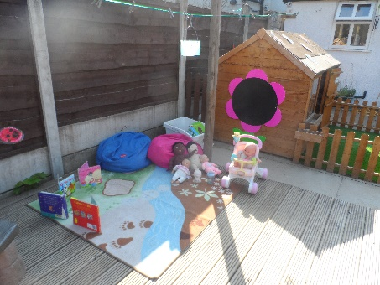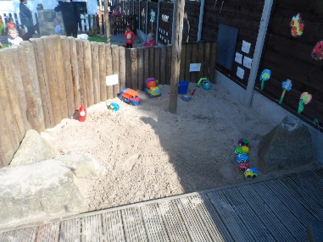
Our Garden
Not only do we spend time in our lovely nursery but we also like to spend time outside, no matter what the weather!
This garden is more for the pre-school and tweenies. Our staff set up activities for our children to go out and play and get some fresh air. Some of these activities include: sand and water, mark making, reading area, slides and construction objects.

Our Main Garden
This garden is used by all age groups at different times of the day

*currently awaiting our main garden to be finished -

The staff do move children’s rooms around to meet children’s individual needs, ages and interests but here is some information about each room and some photos of how they can be set up.

Baby Room (0- 18month/2years)
We have a large room set out with appropriate toys and activities to stimulate play and development. The room is very homely and gives the young ones the opportunity to play, share, choose toys, learn new skills and enjoy their free time, with the support of our qualified team of staff. We encourage favourite toys and/or blankets as they often help to act as a comfort whilst settling in. We place a huge emphasis on care and it’s important to us to get to know you and your child to help achieve this, we devise individual settling in sessions for your child where parents/carers can come and meet staff and tell staff about their child and fill in the relevant paperwork. We have an outdoor play area and we have nursery prams to take the children for a walk in the nicer weather to places such as Heaton Park, where the children can also visit the farm animals. We have space to store pushchairs, or if you are arriving by car, car seats etc. All our staff within the baby room are qualified in ‘Working with 0-2years’
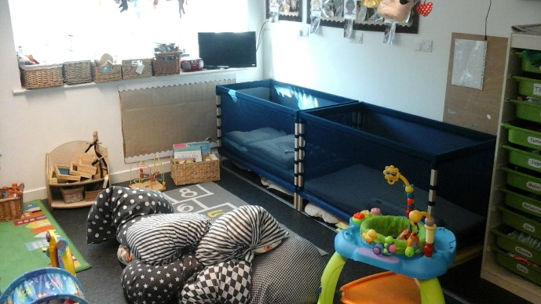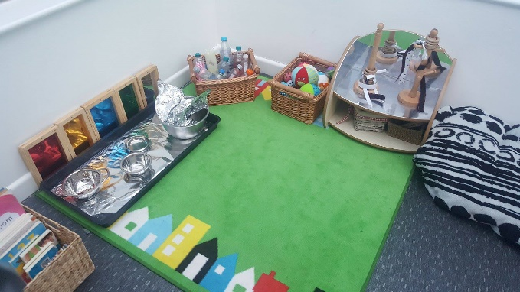

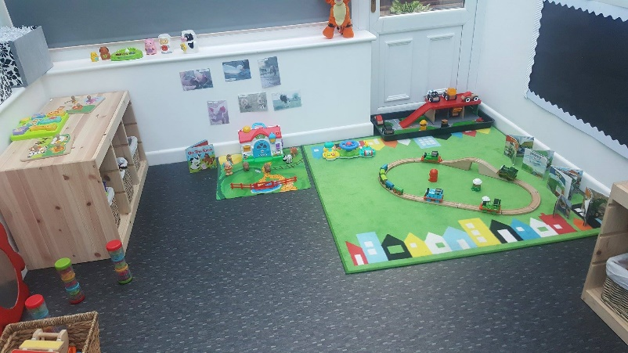

Tweenie Room (18months- 30months)
We have 1 large room set out with age appropriate toys and activities to stimulate play and development. We have a messy / creative area, where they can explore, paint, model and create masterpieces ready to take home. We then have areas which include the book corner, home corner, small world and construction. Space for children to play, learn and enjoy. The day is made up of some adult led activities but there is also time for the children to lead play which with the support of the keyworkers is often the best opportunity to extend their learning and development. Each week the room session plans are displayed for the parents to see, the plan allows for plenty of spontaneous opportunities that often arise with children’s curiosity. At around 2 years of age the children have a 2 year assessment which is completed with your health visitor, we ask for parents to inform us of the date of this assessment so we can do our assessment first which you can then take to the health visitor to give them more insight to their development within nursery.

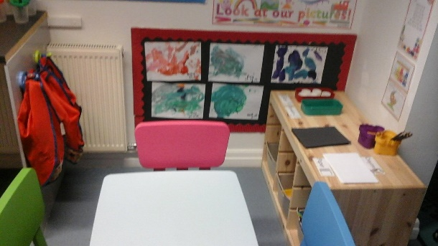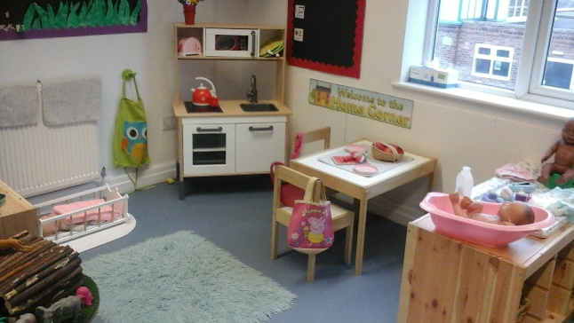

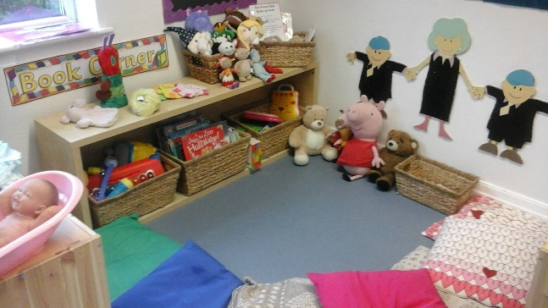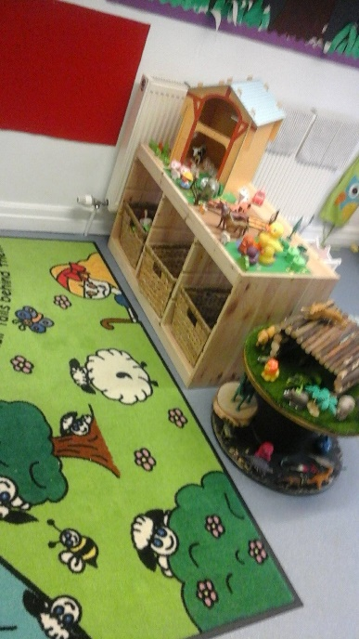

Pre-School Room (30 months-4Years)
From the age of 3 the children join our pre-school group. We follow the Early Years Foundation Stage curriculum in accordance with Government guidelines. 0ur priority is for the children to have fun while they are learning, and to make the most of every opportunity. For example the home corner becomes a pirate ship and even a police station. For pre-school in the term after your child's 3rd birthday you are entitled to receive an education grant (free entitlement) from the government. This will reduce your childcare costs as you are entitled to up to 30 hours of free childcare which the grant pays for. The pre-schoolers have themes that run each term and include having visitors in and making visits themselves. Pre School Parents have the option to allow their child to attend weekly swimming sessions at our local Swimming Pool Ivy Bank Swim School. Children benefit from this greatly with the majority of children all obtaining their 5m- 15m swimming badges, recently we have had 2 of our children gaining their 25m badge!! Pre School also attend regular trips, which may be in accordance to their monthly topics/ interests such as Sea Life Centre for ‘Under the Sea’ topic. We also have annual trips to Blackpool Zoo and Christmas Pantomimes. All our staff within Pre-school have relevant training in regards to getting the children ready for school and training in ‘Letters and Sounds’ etc.

