GM Creative Care kits
26 organisations across Greater Manchester have worked together to make and distribute 22,000 Creative Care Kits to young people with limited internet access.
In Bury we have been given 1,800 kits to share across the young people we are collectively working with. There is another kit planned for the end of July, to be delivered to the same young people. The kits have been designed for 14 – 20 year olds, a photo of the contents and a link to the work book is below.
https://files.cargocollective.com/503103/Creative-Care-Kit-Young-People.pdf
You are welcome to download your own copy of the 36 page book full of ideas, activities and tips to support wellbeing. This resource is free to use by young people, families and those who support young people.

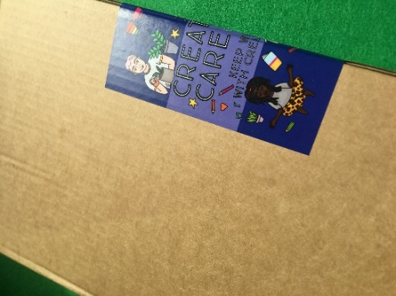 | 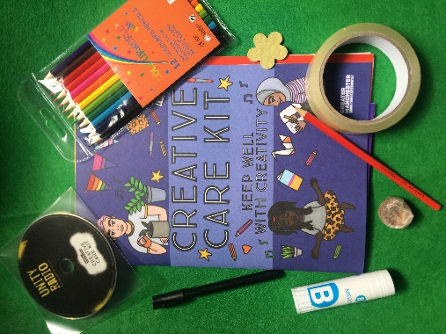
We’re working to ensure that the kits get delivered to the young people who would benefit from them the most. Due to this we’ve devised an approach to enable partners to decide where the kits should go but due to the reach we’re also asking providers to undertake the delivery of the kits.
If you would like to be a part of this project, the instructions are below.
Instructions
- Please have a good look at the workbook to assess the cohort you are working with to ensure appropriateness. If you feel that you have a younger or older young person who would appreciate the kit, then please also include them as the age range is a guidance.
- There is a spread sheet to complete to create a list, asking for very basic details of the young people you’d like to receive a kit.
- Please complete the spread sheet and send back to youthservice@bury.gov.uk by 26th June. Please password protect the document and send the password in a separate email. The separate lists from partners will be collated and cleansed to ensure there is no duplication.
- Partners will then be given a revised list (based on their original) and allocated the number of equivalent kits. Please note, if names have been removed, this is solely due to duplication – those young people will still be receiving a kit.
- Times will be discussed/offered to collect kits from The New Kershaw Centre, BL9 7PZ, following social distancing guidelines.
- Partners must be able to deliver by July 17th – the delivery is the responsibility of partners.

We would also like to collect feedback from yourselves, parents, and young people. A survey monkey has been set up to collate this with a link included in the kits (https://www.surveymonkey.co.uk/r/2Y23M9G), but if you do have feedback on the process or the kits themselves, please pass this on. If you gain informal feedback from the young people you’ve delivered to, again please could you also pass this on via the email youthservice@bury.gov.uk.

