Bury Care Leavers Newsletter
March 2020
CORONA VIRUS UPDATE
Following Government guidance, there will be a reduced service due to the Corona Virus outbreak. Council employees are working from home. Everyone must now stay at home unless it is necessary to go out.
We must all now stay indoors and not go out except for essential shopping, medication or for a solo walk/run or a secluded walk with other members of your household. You must stay at least 2 meters away from other people.
The Care Leaver Offer and Bury Directory will be kept up to date with any developments during this time.
However, we are here for you if you need to contact us, Care Leavers should contact their PA or Social Worker directly.
Please keep checking this page links to support services being put in place across Bury will be updated regularly:
https://www.theburydirectory.co.uk/kb5/bury/directory/health.page?healthchannel=3-15
https://www.theburydirectory.co.uk/ and click on the Care Leaver Offer icon
Please see the links below for information on maintaining your mental wellbeing during this time.
https://www.lifeline.org.au/get-help/topics/mental-health-and-wellbeing-during-the-coronavirus-covid-19-outbreak
https://www.escap.eu/index/coronavirus-and-mental-health/
https://carolgraysocialstories.com/wp-content/uploads/2020/03/Pandemics-and-the-Coronavirus.pdf

Beyond Psychology service:
Beyond Psychology is responding to CoVid-19 in order to reduce the impact of this on people's wellbeing.
Beyond Psychology want to support as many families as they can in these difficult and uncertain times. Therefore, our psychologists and therapists are volunteering on the phones from Monday to Friday to support both children and adults who may need support.
To speak to one of our members of team, click link to go to contact page, enter "CALL ME", provide your phone number, and a few details of how you want to use the phone consultation. The operator will be in touch with you, to arrange the best time to speak.
https://www.beyond-psychology.co.uk/contact/
OTHER NEWS:
Fabulous News Alert
At the Council Budget setting meeting on 26th February, a Fund for Care Leavers was agreed with funding of £100K over two years. The details of the Fund are not, as yet, clear but this is fabulous news for care leavers in Bury and great that you have received recognition from Council Leaders. Watch this space for more details and make sure you go to the Care Leavers Forum to get a say in how these funds are allocated.
Corporate Parenting Champions update
As you all know, a new scheme has been set up to get more corporate parents involved and advocating for care leavers and children in care. There are now over 60 champions across the Council and CCG. The Champions have been doing some good work over the last few months including the appeals for Christmas gifts, sanitary products, toiletries, vouchers and books for a library in The Hub. They have also helped out and used their influence with direct requests from PAs. The next plan is for champions to volunteer their time to support you with some of the everyday help you have told us you need such as DIY, cooking and decorating skills. More details on this to follow.
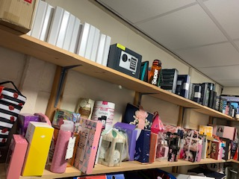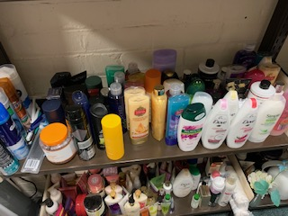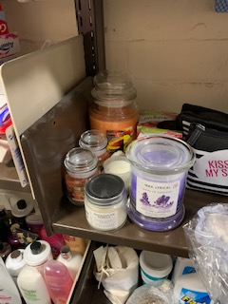
Constituted Group for Care Leavers
A constituted group has now been set up entitled “Friends of Bury Care Experienced Young People”. The constitution has been agreed and the statutory roles been allocated to members. This will allow the group to bid for grants and funding not open to the Council or other statutory agencies. The funding will be used to pay for support and activities that are currently not available to young people through statutory services. The young people themselves will decide where the money is best spent.
If anyone is interested in joining the group, please let me know. We only intend to meet a couple of times a year so it will not be a massive commitment. It would be great to have a group of champions as trustees on this group.
Care Leavers Offer
As you know, we have a dedicated website hosted by The Bury Directory where all care leavers from Bury can access a host of information. This includes events, opportunities and information that may be useful to care leavers www.theburydirectory.co.uk
Please could all care leavers have a look at the website, tell us what you think and be honest. What is missing? What information would you like to see? What do you like about the website? Is it easy to use. There is a feedback form on the website, please let us have your comments using this link. We can only improve the website if you tell us what you want to see
Poem written by Care Leavers Forum, 20 Jan 2020

Our Dreams

I dream of travelling far away
And working in the sun
I’d have a place all of my own
I’d feel like I had won
I dream of having space
Rolling hills and time to think
No one telling me what to do
What to eat and what to drink
I dream of time to just relax
To sleep per chance to dream
To have a job that I enjoy
With an amount of cash that’s just obscene
I simply dream of happiness
To feel secure on my two feet
To have a home I can share
On my own nice, quiet street
My future’s mine and I decide
What, why, where and when
I just need a chance, a break, a hand
I’ll get there in the end

Consultation:
We would like your views and ideas on the following:
- What would you really like Corporate Parenting Champions to do? What could they do to make a difference?
- We have set up a constituted group for care leavers and young people in care (see above). What’s the best way to gather ideas on what is needed by care leavers? We will use the care leaver forum and CiCC but are there other ways?
- Corporate Parents have asked for some case studies from care leavers. This would tell your story and help corporate parents realise what it like is to be in care and the ups and downs of life in care. This would be anonymised. Is anyone interested in doing this? Jacqui would write it, you’d just have to meet her for a chat and you would agree the case study before anyone read it (obviously this would take place after the current Corona Virus Outbreak)
Please contact Jacqui about the above on j.waite@bury.gov.uk
Regular events:
PLEASE NOTE THAT ALL EVENTS ARE CURRENTLY ON HOLD DUE IN LINE WITH CORONA VIRUS GUIDANCE.
Regular events will recommence once the Government Guidance allows social distancing to stop. Once this happens, details of regular events will be found on the Care Leaver Offer www.theburydirectory.co.uk
Update on a few of the Care Leaver comments:

YOU TOLD US : WHAT WE DID :
This issue has been raised at Corporate Parenting Board. In future anyone in HEN properties will be able to request a freezer in their property if they want one.
“We can’t cook healthy meals as we have nowhere to freeze leftovers, it’s cheaper to get meals at Dixie Chicken”

A Corporate Parenting Champion stepped in and waived the charge and delivered a free bin the following day
A strategy is being written to reduce the numbers of NEET care leavers in Bury. Work Experience pathways are being developed to ensure work experience in the Council is easier to access
“We would like to have our voices heard and have a say in how services are planned”
The Care Leaver Forum has been relaunched with opportunities to have your say and speak to professionals based on what you tell us is important to you. A Corporate Parenting Officer is in place to make sure your views are heard across the Council and there are now over 60 Corporate Parenting Champions.
“I’ve moved into a new property but the Council are telling me I can’t have a new wheelie bin unless I pay £35”
“Getting work and work experience can often be an issue”

