**Educational Psychology Service**

**We are Bury Educational Psychology Service**

|  |  |  |  |
| --- | --- | --- | --- |
| Photo |  |  |  |
| **Claire Jackson** | **Jan Playfer** | **Catherine Kelly** | **Kay Bristow** |
|  | Photo of Rachel Lyons | |  |
|  | **Rachel Lyons** | |  |

**The Educational Psychology Service**

Bury Educational Psychology Service (EPS) is working in partnership with Salford EPS and Tameside EPS. Educational Psychologists from these three services work across all areas, to share good practice and project work.

The three services are currently delivering the Wellbeing Return to Education programme, a Department for Education (DfE) funded project to support wellbeing in schools and colleges during the COVID-19 pandemic. More information about this project and other COVID-specific resources for schools and parents/ carers can be found on the Emotionally Friendly Schools Website: [Resources | Emotionally Friendly Settings](https://www.emotionallyfriendly.co.uk/resources/)

**What is an Educational Psychologist?**

Educational Psychologists (EPs) work in partnership with families, schools, settings and other professionals to achieve positive outcomes for children and young people aged 0-25. Sometimes a school or setting might ask an EP to be involved to support pupils who have needs in any of the following areas:

* Play and/ Learning;
* Speech and language;
* Social interaction;
* Emotional development/mental health and wellbeing needs;
* Physical (fine/gross motor, medical conditions);
* Sensory needs (hearing, vision, sensory sensitivities).

Many children have needs within their development and learning at some point in their lives. Most improve with the help of their families, their schools and their friends. The Educational Psychology Service can offer additional advice and support.

Educational Psychologists (often known as EPs) aim to help others meet children and young people’s needs in an informed and inclusive manner. EPs are generally asked to become involved with children who may be experiencing some difficulties to help provide a clearer understanding of their strengths and needs and supported needed to make progress. We usually work through cycles of Assess-Plan-Do-Review.

**Before an EP is involved:**

* If you have particular concerns about your child you may want to discuss these with the Class Teacher/Key Person and/or Special Educational Needs Coordinator (SENCo). The SENCo may then request EP involvement if they would like further support and advice.
* If EP involvement is appropriate, a member of school/setting staff will speak to you about how we might help your child and you will be asked if you would like to go ahead with EP involvement.
* If you have any questions about our involvement you can ask staff or contact the EP service directly using the details below.
* The school/setting will arrange our visit.

**During EP involvement:**

We will want to meet with you and school/setting staff to find out about your child’s interests, strengths, needs and future goals and aspirations. You know your child best so your views are invaluable in developing an understanding of their strengths and needs.

[](https://www.google.co.uk/url?sa=i&rct=j&q=&esrc=s&source=images&cd=&cad=rja&uact=8&ved=2ahUKEwiQz5yw6__YAhUG0xQKHZwHD9kQjRx6BAgAEAY&url=https://www.thebalance.com/how-to-plan-a-small-meeting-1223672&psig=AOvVaw0RpWlvXPj5Rdisln5nsbZk&ust=1517406892911943)

Our involvement might also include:

[](http://www.google.co.uk/url?sa=i&rct=j&q=&esrc=s&source=images&cd=&cad=rja&uact=8&ved=2ahUKEwjw7_mr7P_YAhVK1xQKHZzlBKMQjRx6BAgAEAY&url=http://thechildpsychologist.co.uk/attention-deficit-hyperactivity-disoder-adhd/&psig=AOvVaw3Hag6f92UmpdzHx_v2Kvzo&ust=1517407151144135)

* Meeting with your child to gather their views and individual assessment of strengths and needs

[](http://www.google.co.uk/url?sa=i&rct=j&q=&esrc=s&source=images&cd=&cad=rja&uact=8&ved=2ahUKEwiN-d_V7P_YAhXBNxQKHU46Bf4QjRx6BAgAEAY&url=http://www.gettingsmart.com/2016/12/21st-century-classroom-design/&psig=AOvVaw2HN9ucxxSy8HFGf4xTVVTv&ust=1517407225007921)

* Observations

[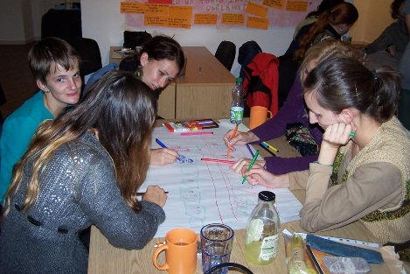](http://www.google.co.uk/url?sa=i&rct=j&q=&esrc=s&source=images&cd=&cad=rja&uact=8&ved=2ahUKEwj7m-jk7f_YAhUCXBQKHYD9Ce0QjRx6BAgAEAY&url=http://www.personcentredplanning.eu/index.php/latest-news/207-meeting-takes-place-between-czech-and-slovak-members&psig=AOvVaw3RusG-pIv6VijrbwcUpkir&ust=1517407547987347)

* Person-centred meetings

[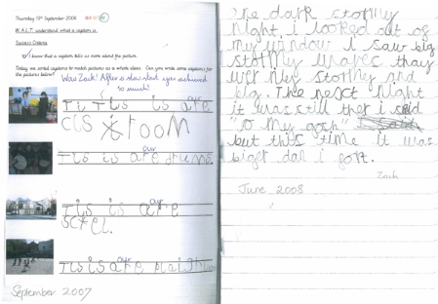](http://www.google.co.uk/url?sa=i&rct=j&q=&esrc=s&source=images&cd=&cad=rja&uact=8&ved=2ahUKEwia8ovS7v_YAhUFXBQKHVdjDsYQjRx6BAgAEAY&url=http://www.soundreadingsystem.co.uk/testimonials/childrens-work/&psig=AOvVaw0GuU-t1UL5aRmKrLNAu7e-&ust=1517407757830831)

* Looking at children’s work

[](https://www.google.co.uk/url?sa=i&rct=j&q=&esrc=s&source=images&cd=&cad=rja&uact=8&ved=2ahUKEwi8o7ul7__YAhUEbRQKHU2pDzUQjRx6BAgAEAY&url=https://learn.cli.org/best-practices/writing-workshop/instruction/work-time&psig=AOvVaw38F93vhE4YCHIoYYGqarPE&ust=1517407948256935)

* Individual or group intervention

The next steps will be agreed so that everyone is clear who is doing what and by when and a written record will be sent to the school/setting and you.

**Phrases families have used to describe our service:**

“Value my views”

“Listened to my perspective on my child’s needs”

“Listen”

“Family centred”

“Friendly”

“Supportive”

“Easy to talk to”

“Responsive”

**Please feel free to contact the EP team:**

**Bury Educational Psychology Service**

3 Knowsley Place

Duke Street

Bury

BL9 0EJ

Telephone: 0161 253 6406

[edpsych@bury.gov.uk](mailto:edpsych@bury.gov.uk)