**How I can help you**

I know all of the schools in Bury really well and can often help children, young people and their families to talk with schools when a problem arises. I can help families to get in touch with the right services so that their children’s education will work out successfully.

[c.atherden@bury.gov.uk](mailto:c.atherden@bury.gov.uk)

**Name:** Cath Atherden

**Role:** Service Manager, Inclusion

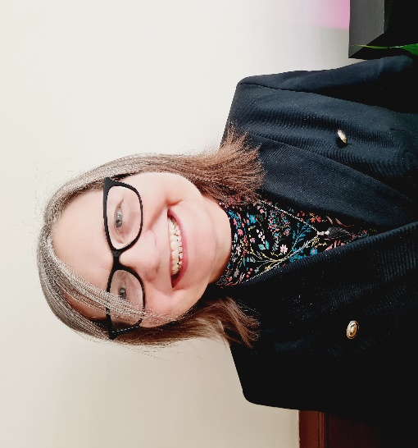

**PROFESSIONAL PROFILE**

**About my role**

I oversee the teams in Inclusion Service to make sure we are all working together to support Bury’s children and young people:

* Additional Needs Team
* Educational Psychology Service
* Inclusion Ambassador and Young People’s SEND Advocate
* Primary Inclusion Leads
* Primary SEMH Outreach Team
* Sensory Support Service

I also support children, young people and their families if there are difficulties with a school placement.

**About me**

I was born and grew up in Bury and went to Bury schools. I have lived and worked here all my life. I used to be a teacher in Bury and then came to work for the Local Authority in 1998.

I try really hard every day to make sure that children and young people with additional needs or special educational needs get the education they want and deserve. This is the most important part of my job.

When I’m not at work, I like to spend time gardening, especially growing my own fruit, veg and herbs. I enjoy cooking and baking too and I am a cat lover ☺