Ellie Lorenzo
Inclusion Services
My job is to work with you to help you with any learning differences that you may have. I am a Specialist teacher. So I will try with your help to find the right ways to help you learn and get better. I work for a team called ANT. We are the Additional Needs Team.

All about me?
I have worked in Bury for over 10 years. I have taught in lots of different schools in the North West.
I am married and have a son who has learning difficulties. I like to play at the park with him and we like to bake together. We like to go on walks, playing scrabble and cards.

What I am really good at?
- I like reading, I do lots of reading
- I like to keep fit and healthy. I like to go to fitness classes at the gym
- I am a good singer. I have sung in lots of choirs
- I like to cook. Favourite meal to cook is Paella

What I am not so good at?
- I find art really difficult, I don’t like drawing
- I find ‘ipad’s’ very difficult to use
- I can’t ice skate. I always fall over

Things I like 😊
- Chocolate
- Olives
- Fresh flowers
- Laughing
- Talking with my friends
- My job
Things I don’t like ☹
- Rude people
- Raw onions
- Marrow

What I would like to get better at?
- I would really love to speak Spanish
- Being neater
- Running
I hope to run ½ marathon some day! 😊

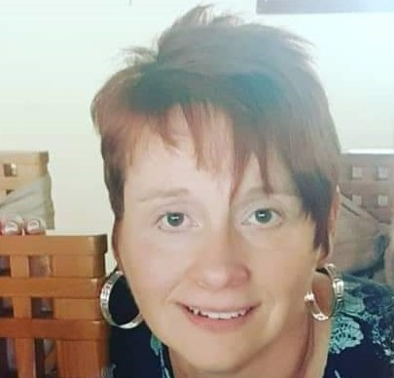
What will I do when I am working with you?
My role is to help you improve your learning, in any way I can.
I may:
Ask you about yourself and what you like to do?
Ask you what you like about school?
Ask you what you don’t like about school?
I will ask you what you think you struggle with and what you think might help?
I may ask your family the same questions?
I may give you different activities so that your school and family can have a better understanding of how you learn.

