Building site

[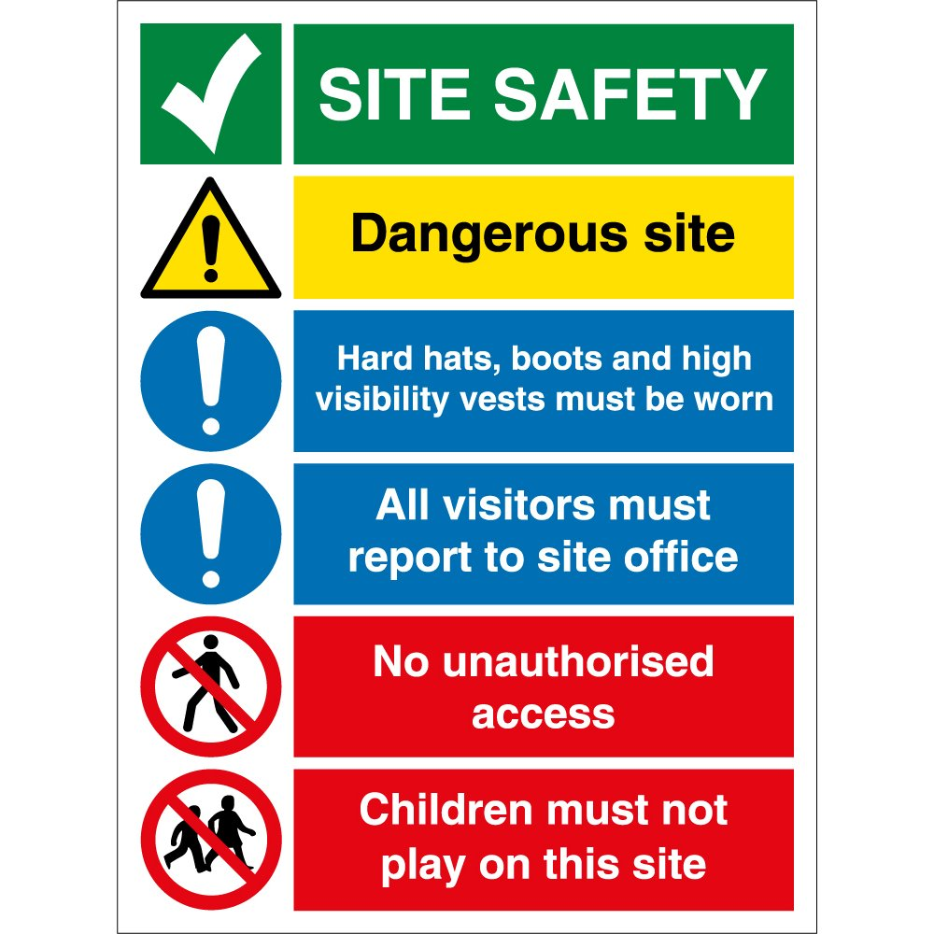](http://www.google.co.uk/url?sa=i&rct=j&q=&esrc=s&source=images&cd=&cad=rja&uact=8&ved=2ahUKEwjw5d2J2vvcAhXpyIUKHcNEAEsQjRx6BAgBEAU&url=http://www.keysigns.co.uk/signs-c2/safety-signs-c3/construction-site-safety-signs-c255/site-safety-signs-c258/construction-site-safety-signs-p635&psig=AOvVaw0Wz-s6TrMJILPVGaAi85b7&ust=1534857002080561)