LEGO Position Description Support
(The ENGINEER can use this to tell the BUILDER where to put the pieces)

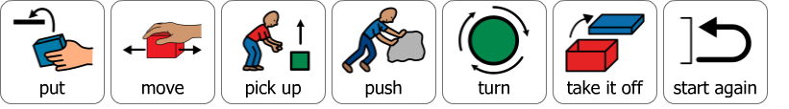
What action?

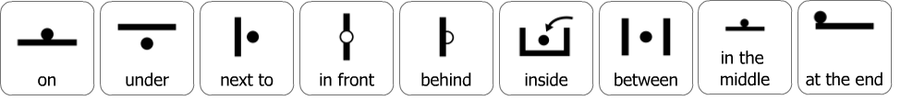
Where?

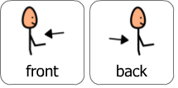
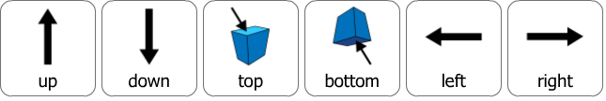

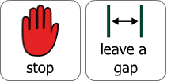
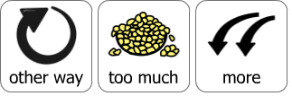
We need to make a change…

