**Lego Group Instructions**





**Step 1**

Piece/Pieces we need: 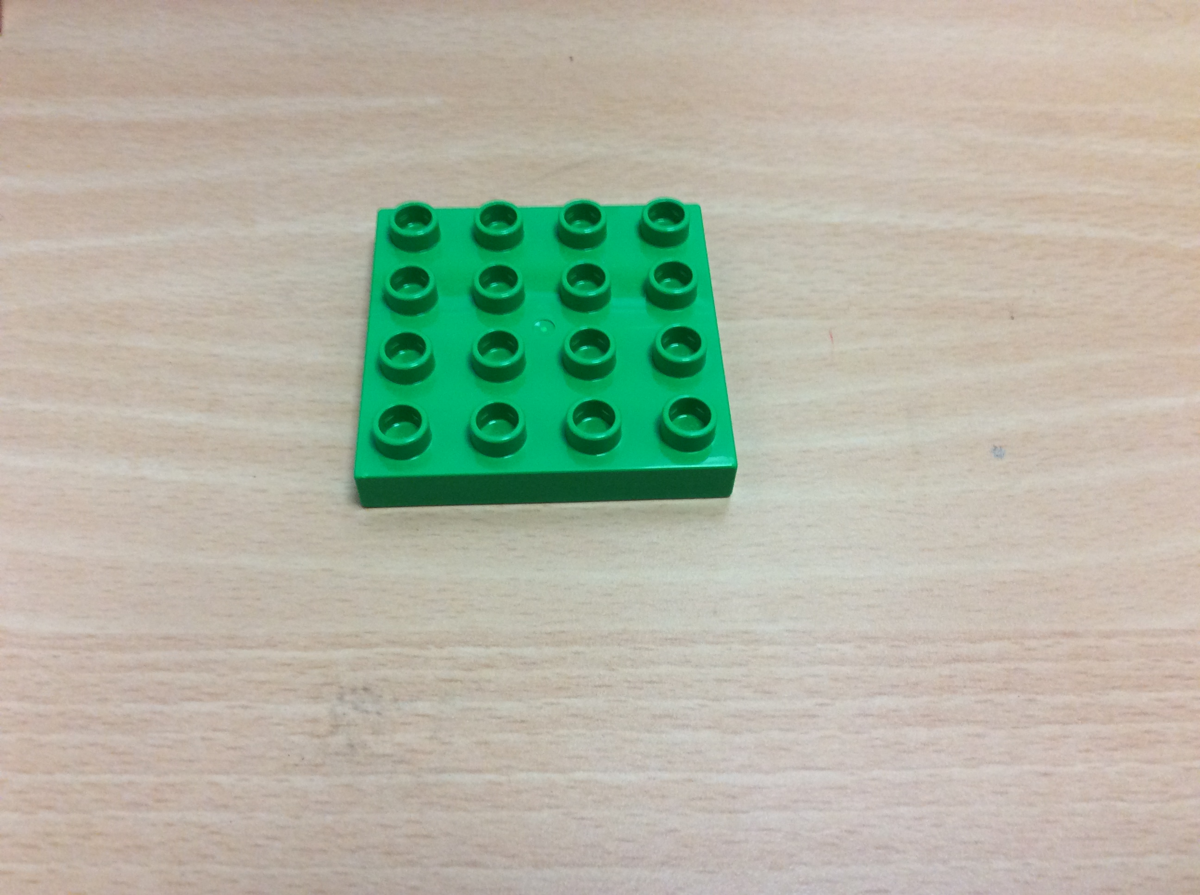

What does it look like ?e?

**Step 2**

What does it look like? 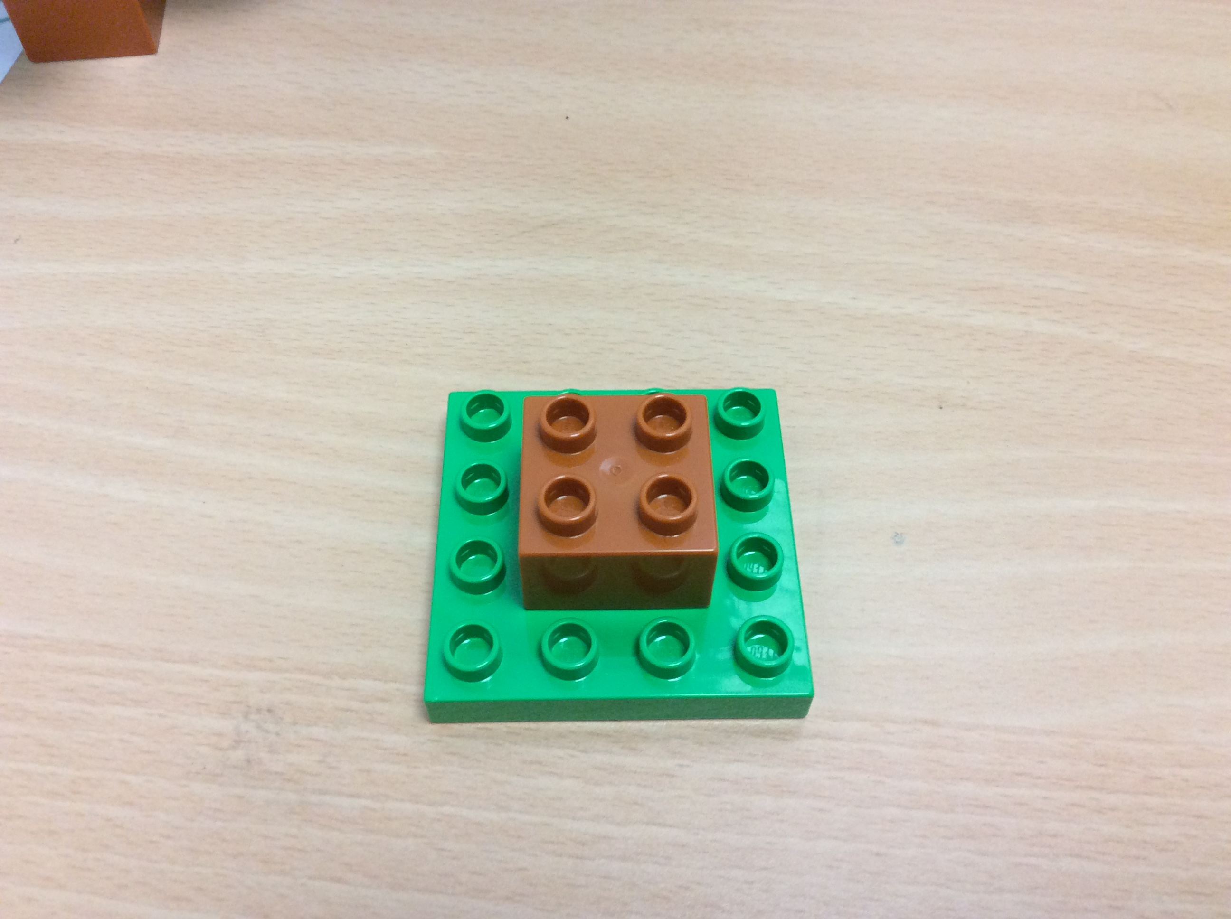

Piece/Pieces we need: 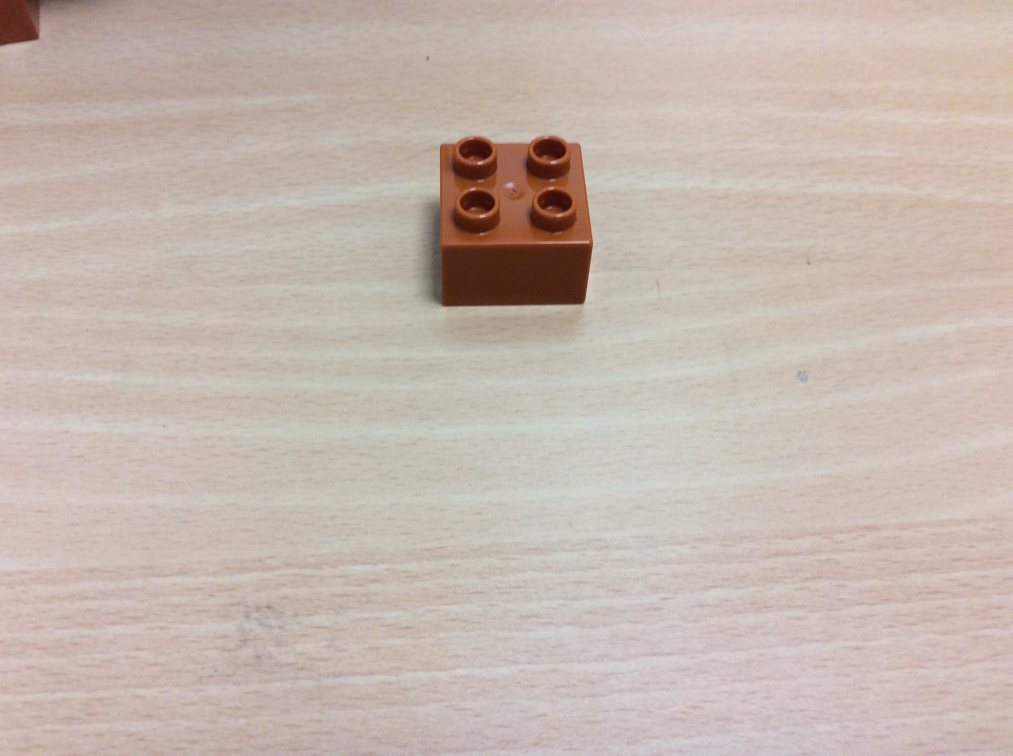

**Step 3**

What does it look like?

Piece/Pieces we need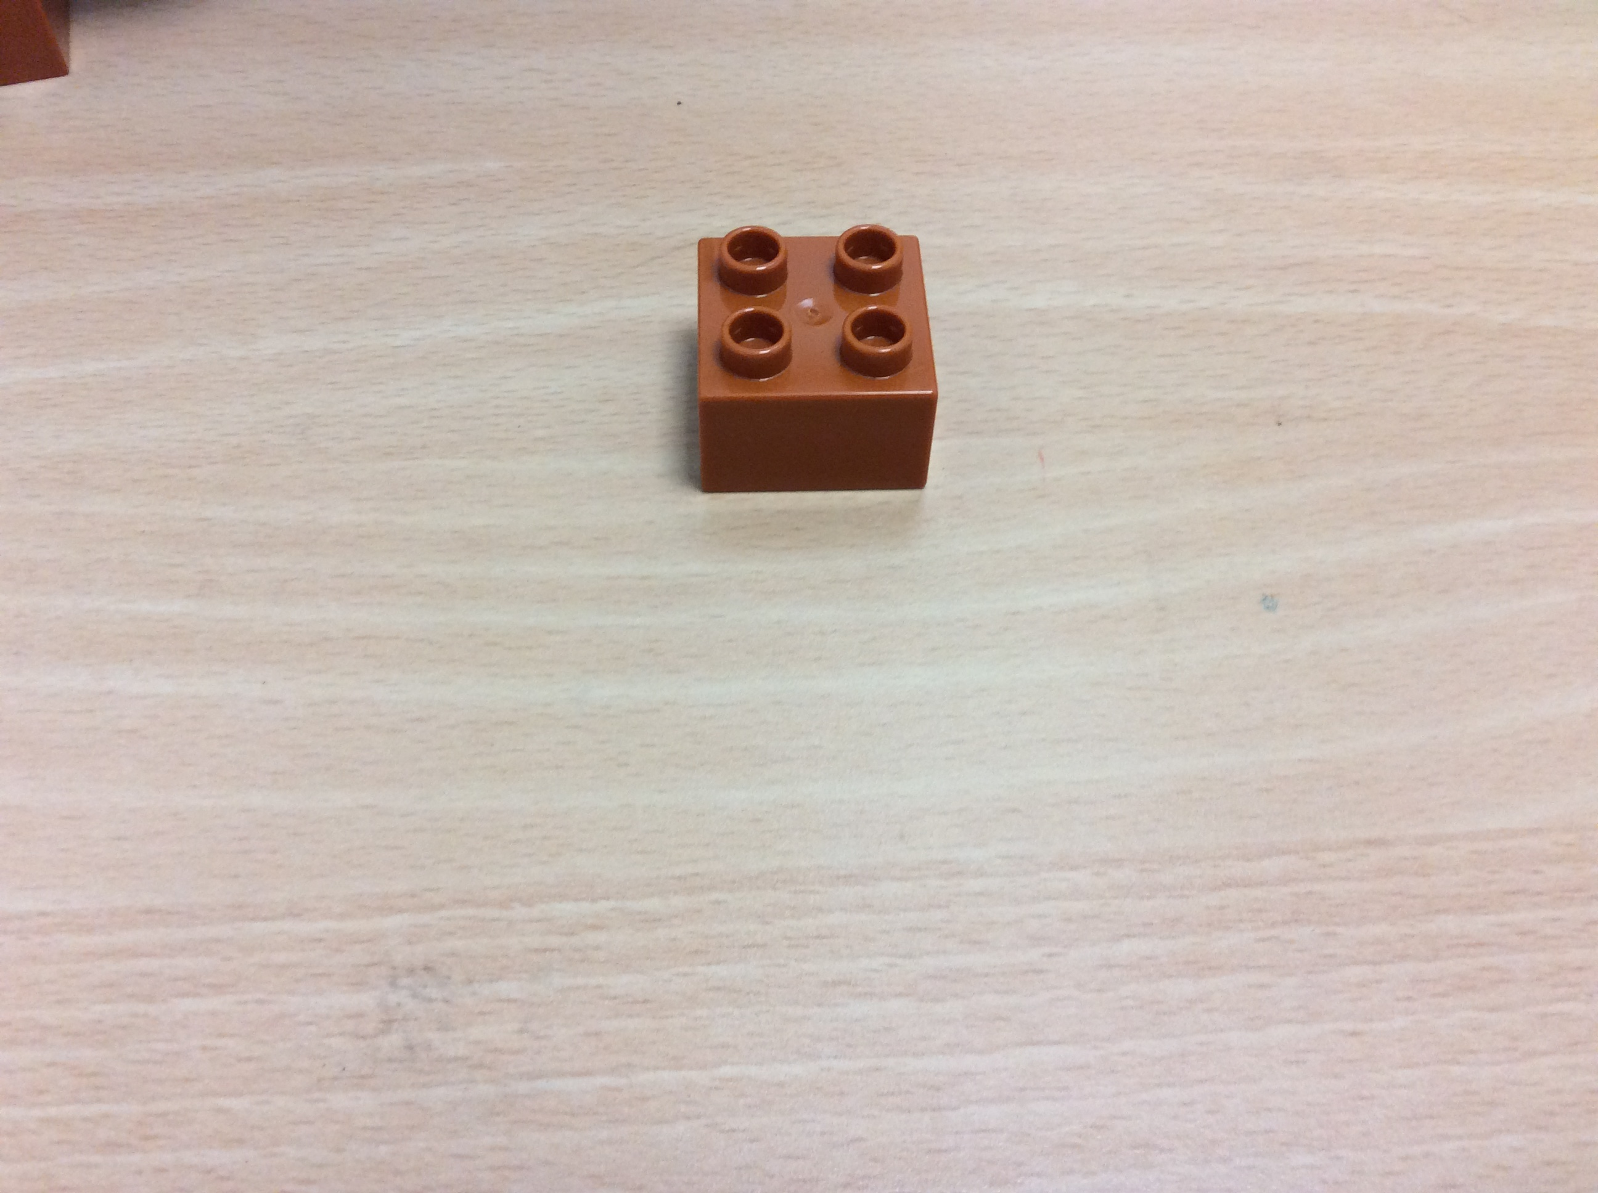:

**Step 4**

What does it look like?

Piece/Pieces we need:

**Step 5**

What does it look like?

Piece/Pieces we need:

**Step 6**

What does it look like?

Piece/Pieces we need:

**Step 7**

What does it look like?

Piece/Pieces we need:

**Step 8**

What does it look like?

Piece/Pieces we need:

**Step 9**

What does it look like?

Piece/Pieces we need:

**Step 10**

What does it look like?

Piece/Pieces we need:

**Step 11**

What does it look like?

Piece/Pieces we need:

**Step 12**

What does it look like?

Piece/Pieces we need:

**Step 13**

What does it look like?

Piece/Pieces we need:

**Step 14**

What does it look like?

Piece/Pieces we need:

**Step 15**

What does it look like?

Piece/Pieces we need:

**Step 16**

What does it look like?

Piece/Pieces we need:

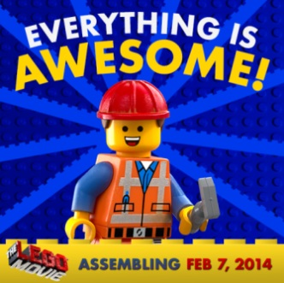

**You did it!!!**