Oral health risk assessment & care plan

Clients full name:
Known as:
Client’s date of birth:
Address/Room no:

Please circle relevant answer
 | Assessment | Suggested action for care plan
1. | Does the person have any natural teeth? Y/N  Do they need help cleaning their teeth? Y/N  Type of support needed: | If yes get prescription for high fluoride toothpaste prescription from dentist Explore support needed to clean twice per day with soft toothbrush and pea sized amount of toothpaste
2. | Does the person have dentures? Y/N  Do they need help cleaning their dentures? Y/N  Are the dentures labelled? Y/N | If yes encourage cleaning morning and night. Clean mouth with moist gauze, rinse dentures after meals, Leave out at night & soak in water overnight. If no-label dentures
3. | Cleaning teeth  Preferred toothbrush & toothpaste: | Consider whether adapted toothbrush or specialist toothpaste is needed
4. | Routine: Preferred time:  Location:  Have previous mouth care routines been discussed with residents/ relatives? Y/N
5. | Is the person experiencing any problems? e.g. pain, difficulty eating, loose dentures#, ulcers, bad breath* | Circle any issues  - Dry mouth  - Saliva substitutes  - Fluorides  - Support with cleaning
6. | Looking at the person’s mouth can you see any problems?  dry mouth#, redness at corner of lips, dirty teeth, red gums or mouth, ulcers*, bleeding gums, poorly fitting dentures, broken teeth#.  Photo where possible | Circle any issues  - Dry mouth  - Saliva substitutes  - Fluorides  - Support with cleaning
7. | Cognitive/ behavioural issues
8. | Relevant medical history  e.g. smoking, medication, alcohol, speech & language, dietetics*
9. | Name and address of dentist:  Next appointment due:  Do they need to pay for treatment? Y/N | If unsure about payment help them to complete a HC1 form

Signed:
Job title:
Date:
Care Plan Key:
# Red Underlined issues- contact dentist
* Blue Italics- additional care needed
NB: Assessment to be reviewed on a 3 monthly basis or sooner if any changes are noted.
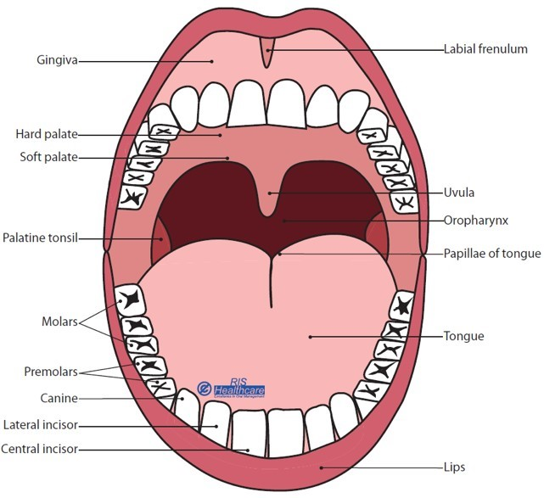
Graphic reproduced with kind permission from RIS Healthcare

