Daily Log of Mouth care
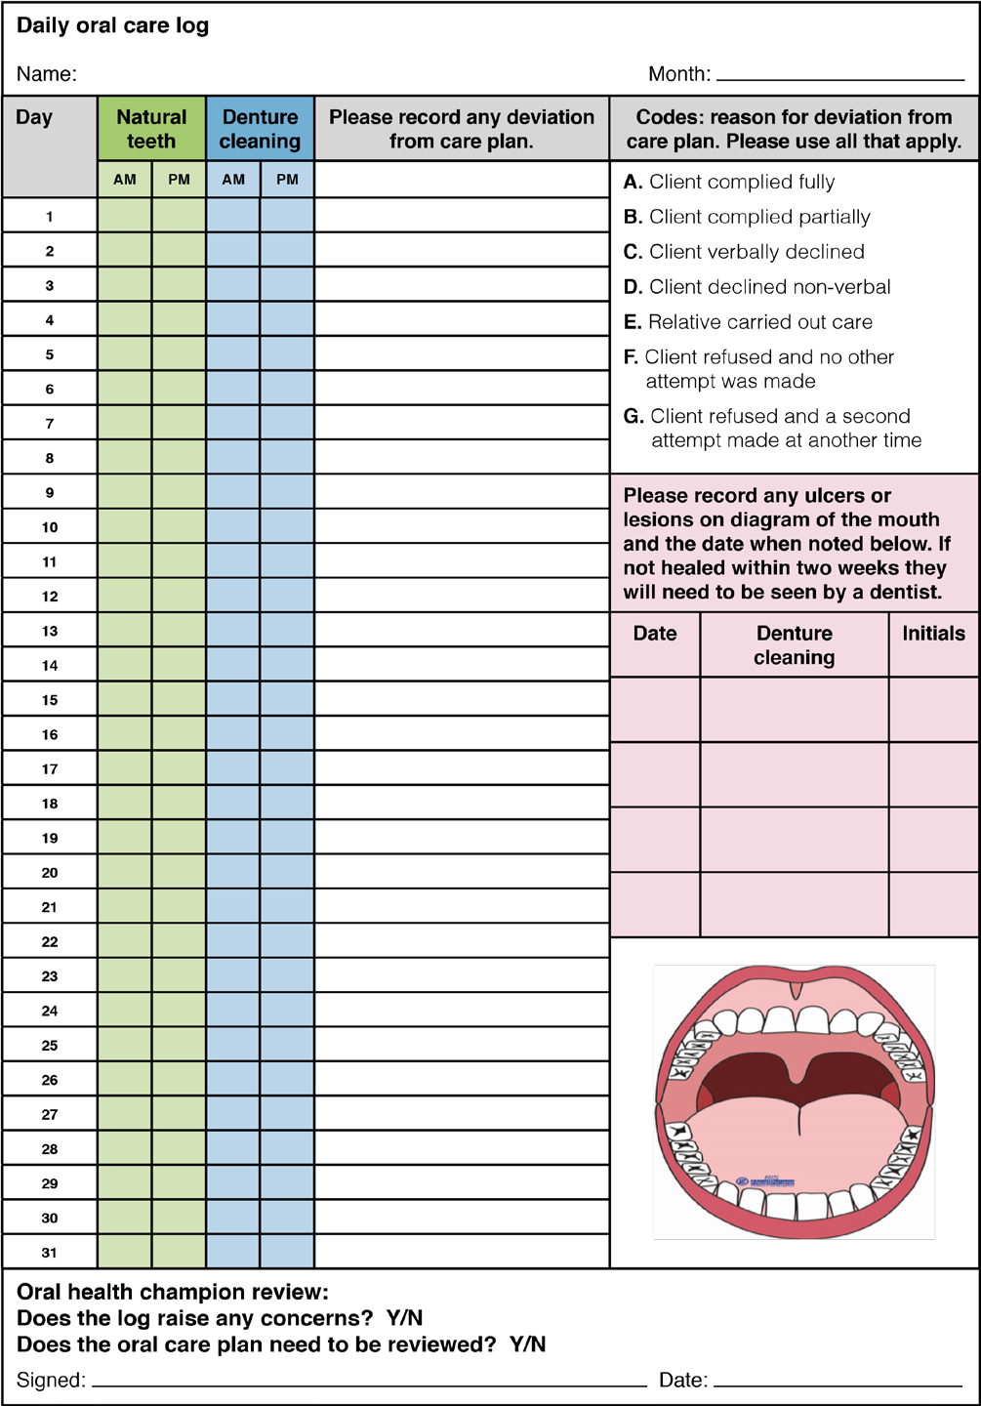Reproduced with kind permission from RIS Healthcare

