Daily Log of Mouth care for people with cognitive impairment or dementia

Not all clients can complete this task themselves and require care staff to remove their denture, clean them and put them to soak. This task is very important not only for the dignity of the client, but also reduces problems with mouth infections, ulcers, thrush etc. Tick the box for which area you have cleaned and if there are any concerns.
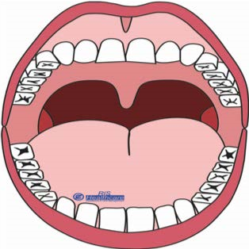

Area 1

Area 2

Area 3

Area 4

Area 5

Area 6

Date | Area 1 | Area 2 | Area 3 | Area 4 | Area 5 | Area 6 | Comments | Signature

Reproduced with kind permission from RIS Healthcare

