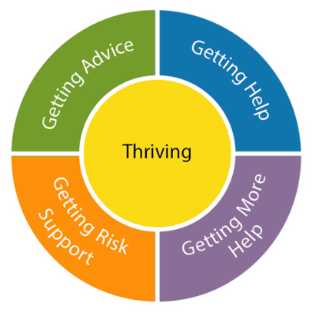
EBSA Support Pathway
- CONSENT FORM -

Multiagency response to children anxious to return to school (emotionally based school avoidance; EBSA)
To co-ordinate multiagency support around children and young people who are anxious about attending school or college (emotionally based school avoidance; EBSA) a new way to access support has been developed.
This includes a graduated approach to meeting need using the Thrive Framework and collaboration between different services (Early Help, Educational Welfare Service, Inclusion Service, CAMHS Link Programme, Educational Psychology). For children and young people with complex support needs this consent form will allow your child/ young person’s needs to be discussed as part of the Early Help service’s Team Around the School (TAS) approach, to identify a Lead Professional to co-ordinate support. Further consent for the direct involvement of specialist services will be sought from you as needed (e.g. CAMHS, Educational Psychology).
Name of pupil: |  |  |  |  | DOB:
School / provision:
Year Group
Current attendance:
Key contact in school:
Contact details: |  | Email |  | Tel.
Parent/carer details: |  |  |  | Tel.
 |  |  |  | Tel.

Services already involved:

Early Intervention
Steps taken and support offered to date (to be completed by school/setting/ referrer)
It is expected that prior to a referral into the pathway assessment tools will have been completed and used to inform plan-do-review intervention cycles. Please attach completed assessment tools/ analysis summaries and support plans, and summarise any actions taken and the impact of these below.

PARENTAL CONSENT:
- For the information on this form to go on the computer database (Educational Management system).
- For liaison with other professionals including (but not limited to) those listed above (this could be conversations or sharing written information).
- For advice/ support to be given to your child/ young person’s school by professionals from the services listed above. This may include the use of tools to gather your/ your child’s views in relation to school.
- Referrals for direct support (e.g. assessment, observation, consultation with staff, direct work with your child). Further consent for the direct involvement of specialist services will be sought (e.g. Educational Psychology, CAMHS).
Please sign below:
Parent/carer:……………………………………………………………………………..Date…………………………
Name and role of person who obtained consent:…………………………………………………………..
- Tick here if you do not wish for anonymised information to be used in training case studies (this will not affect the referral).

Signature: | Parent |  | Date
 | Professional |  | Date

Please return completed forms to the Early Help inbox:
Earlyhelp@bury.gov.uk

