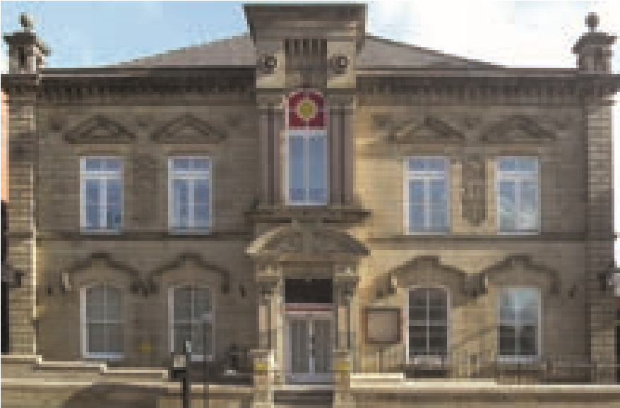
32293 What Do You Think Booklet.indd 1-2 11/10/2013 09:48
Adult Care Services
What do you

think?
Do you have a comment, complaint or compliment about our services?
We want to hear from you!
Translation and Interpretation Services
We are committed to providing a high-quality service to all our
customers, including those whose first language is not English.
If you need help with translation or interpretation or would like a
copy of this document in large print, on audio tape, on CD or in
Braille, please phone Bury Council Customer Advice and Liaison
Team on 0161 253 6021 or send an email to: calteam@bury.gov.uk
Further information
For more information, contact the Customer Services Manager at:
Textile Hall
Manchester Road
Bury BL9 0DG
Tel: 0161 253 5151
October 2013

Listening to you
We are committed to providing a good quality and fair service. However, we sometimes make mistakes. When this happens, it is important that you let us know. This can help us to put things right for you and for everyone else who uses our services. This is why your voice counts!

Comments, complaints or compliments
You can use this form to make any comments, complaints or compliments about our services or the way we have treated you. We always aim to improve our services so we need to know where we are performing well, as well as where we can improve.
To make a comment, complaint or compliment, fill in the form enclosed in this booklet and either:
- hand it in at the place you are making your comment, complaint or compliment about; or
- send it to the Customer Services Manager at the address provided on page 4 of this booklet; or
- send an email to adultcareservices@bury.gov.uk; or
- call into any main council office; or
- phone the Contact Centre on 0161 253 5151
You can also visit our website at www.bury.gov.uk/Adults Insert Adult Care Comments and Complaints in the search box and follow the link.
You do not have to make a comment, complaint or compliment yourself - someone such as a relative, a friend or someone from a voluntary agency can do it for you.
We will deal with all complaints fairly and professionally in line with the statutory complaints procedure for all Adult Social Care Departments in England.
2
What happens next?
We will write to acknowledge receipt of your complaint within 3 working days and ask if you would find it helpful to meet with a member of complaints staff to discuss how your complaint will be handled.
We will advise you who will investigate your complaint and about timescales for this. We always try to resolve complaints fairly, and in the shortest time possible.
If you feel you need help from an advocate we can arrange this for you.
We will provide you with all the necessary information in relation to the issues you have raised with us and, where appropriate, offer a resolution.
Your feedback about our services gives us a valuable opportunity to learn and improve. We will let you know what actions we will take as a result of our enquiries into the issues you raised.
If you are dissatisfied with the outcome of your complaint or the way your complaint has been handled you can contact the Local Government Ombudsman at:
PO Box 4771
Coventry CV4 0EH
Tel: 0300 061 0614
Fax: 024 7682 0001
Email: advice@lgo.org.uk
There may be occasions when it is appropriate for the Care Quality Commission to be made aware of complaints e.g. in respect of regulated care services such as the standard of care in a residential home. The commission can be contacted at:
Care Quality Commission
North West Regional Contact Team
Citygate, Gallowgate,
Newcastle Upon Tyne NE1 4PA
Tel: 03000 616161
9

32293 What Do You Think Booklet.indd 3-4 11/10/2013 09:48

