Children's Community Nursing Team - Bury
An information guide
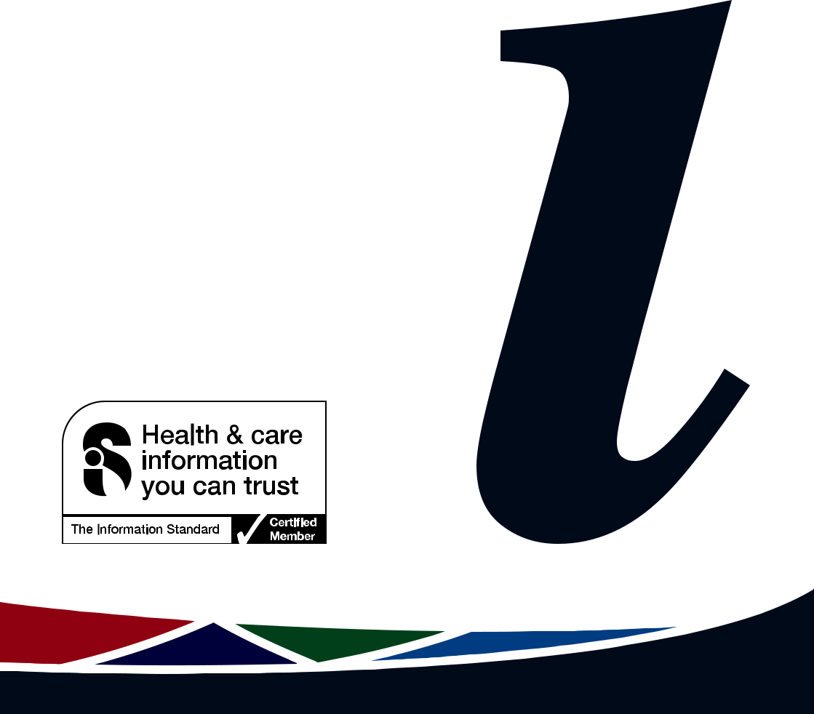
Who are we?

The Children’s Community Nursing Team consists of Registered Children‘s Nurses with hospital and community experience. The team structure comprises of a Team Lead, a Specialist Diabetes Nurse, a Complex Needs Nurse, Senior Nurses, Staff Nurses, Health Care Support Worker and an Administrator.

We work with parents/carers within the Bury area to provide nursing care, support and health education for Children and Young People aged 0 to 18 years (19 years if complex, in full time education or under a paediatric consultant).

Our aim

We aim to ensure the child or young person can receive nursing care and treatment in the community setting for both acute and chronic conditions which can be delivered either at home or in one of our children’s clinics dependent on their needs.

Our service

The Children’s Community Nursing Team can provide a range of treatments and include the following examples:

- Intravenous Medicines/Injections

- Wound care

- Post-operative care

- Nasogastric tubes (NGT) and gastrostomies
- Complex needs

- Management of respiratory conditions

- Management of eczema

- Management of constipation
- Support with Epilepsy Management

- End-of-Life and Palliative care

- Oncology

2

If you would like us to see a child who does not fit into any of the above categories please contact us to discuss the required care.

Who can refer?

We accept referrals by phone, fax, e-mail and letters from all community and hospital health professionals (GP, consultant, Health Visitor, School Nurse)

When are we available?

We are available seven days per week, 365 days a year between 8am and 8pm. If you require medical advice out of hours, for non-emergency urgent care please call NHS 111. In an emergency dial 999 or attend your nearest A&E.

If you would like more information about the service please contact:

Children‘s Community Nursing Team,
3rd Floor Radcliffe Primary Care Centre,
69 Church Street West,
Radcliffe,
M26 2SP

Telephone: 0161 724 2137

During and out of hours you can leave a message on the answer phone stating your name and telephone number and a member of the team will contact you as soon as possible.

Online Directory:

The Bury Directory provides a wealth of information about local and national services that are available for families and professionals who work with children and young people.
Visit: www.theburydirectory.co.uk

3

If English is not your first language and you need help, please contact the Interpretation and Translation Service

Jeśli angielski nie jest twoim pierwszym językiem i potrzebujesz pomocy, skontaktuj się z działem tłumaczeń ustnych i pisemnych

تﻣدﺧ ہﻣﺟرﺗ روا ﯽﻧﺎﻣﺟرﺗ مرﮐ هارﺑ ، وﺗ ﮯﮨ ترورﺿ ﯽﮐ ددﻣ وﮐ پآ روا ﮯﮨ ںﯾﮩﻧ نﺎﺑز ﯽﻠﮩﭘ ﯽﮐ پآ یزﯾرﮕﻧا رﮔا ںﯾرﮐ ہطﺑار ﮯﺳ

Dacă engleza nu este prima ta limbă și ai nevoie de ajutor, te rugăm să contactezi Serviciul de interpretare și traducere

ইংরাজী যিদ আপনার .থম ভাষা না হয় এবং আপনার সাহােয9র .েয়াজন হয় তেব অনু=হ কের ?দাভাষী এবং অনুবাদপিরেষবা@েত ?যাগােযাগ কBন

ﺔﯾرﯾرﺣﺗﻟاو ﺔﯾوﻔﺷﻟا ﺔﻣﺟرﺗﻟا ﺔﻣدﺧﺑ لﺎﺻﺗﻻا ﻰﺟرﯾﻓ ، ةدﻋﺎﺳﻣ ﻰﻟإ جﺎﺗﺣﺗو ﻰﻟوﻷا كﺗﻐﻟ ﻲھ ﺔﯾزﯾﻠﺟﻧﻹا نﻛﺗ مﻟ اذإ

: 0161 627 8770

: interpretation@pat.nhs.uk

To improve our care environment for Patients, Visitors and Staff, Northern Care Alliance NHS Group is Smoke Free including buildings, grounds & car parks.

For advice on stopping smoking contact the Specialist Stop Smoking Service on 01706 517 522

For general enquiries please contact the Patient Advice and Liaison Service (PALS) on 0161 604 5897

For enquiries regarding clinic appointments, clinical care and treatment please contact 0161 624 0420 and the Switchboard Operator will put you through to the correct department / service

The Northern Care Alliance NHS Group (NCA) is one of the largest NHS organisations in the country, employing 17,000 staff and providing a range of hospital and community healthcare services to around 1 million people across Salford, Oldham, Bury, Rochdale and surrounding areas. Our Care Organisations are responsible for providing our services, delivering safe, high quality and reliable care to the local communities they serve.

The NCA brings together Salford Royal NHS Foundation Trust and the hospitals and community services of The Royal Oldham Hospital, Fairfield General Hospital in Bury, and Rochdale Infirmary (currently part of The Pennine Acute Hospitals NHS Trust).

www.facebook.com/NorthernCareAllianceNHSGroup
www.linkedin.com/company/northern-care-alliance-nhs-group Northern Care Alliance NHS Group (NCA) @NCAlliance_NHS

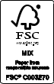
Date of publication: September 2020
Date of review: September 2020
Date of next review: September 2022
www.pat.nhs.uk
Ref: PI(DS)694
© The Northern Care Alliance NHS Group www.northerncarealliance.nhs.uk

