# **Ellie Lorenzo**

# **Inclusion Services**

My job is to work with you to help you with any learning differences that you may have. I am a Specialist teacher. So I will try with your help to find the right ways to help you learn and get better. I work for a team called ANT. We are the Additional Needs Team.

## **All about me?**

I have worked in Bury for over 10 years. I have taught in lots of different schools in the North West.

I am married and have a son who has learning difficulties. I like to play at the park with him and we like to bake together. We like to go on walks, playing scrabble and cards.



### **What I am really good at?**

* I like reading, I do lots of reading
* I like to keep fit and healthy. I like to go to fitness classes at the gym
* I am a good singer. I have sung in lots of choirs
* I like to cook. Favourite meal to cook is Paella

### **What I am not so good at?**

* I find art really difficult, I don’t like drawing
* I find ‘ipad’s’ very difficult to use
* I can’t ice skate. I always fall over



Things I like 😊

* Chocolate
* Olives
* Fresh flowers
* Laughing
* Talking with my friends
* My job

Things I don’t like ☹

* Rude people
* Raw onions
* Marrow

What I would like to get better at?

* I would really love to speak Spanish
* Being neater
* Running

I hope to run ½ marathon some day! 😊



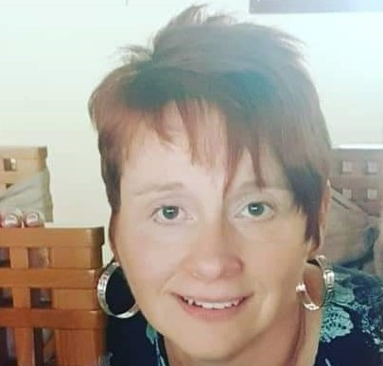

**What will I do when I am working with you?**

My role is to help you improve your learning, in any way I can.

I may:

* Ask you about yourself and what you like to do?
* Ask you what you like about school?
* Ask you what you don’t like about school?
* I will ask you what you think you struggle with and what you think might help?
* I may ask your family the same questions?
* I may give you different activities so that your school and family can have a better understanding of how you learn.





