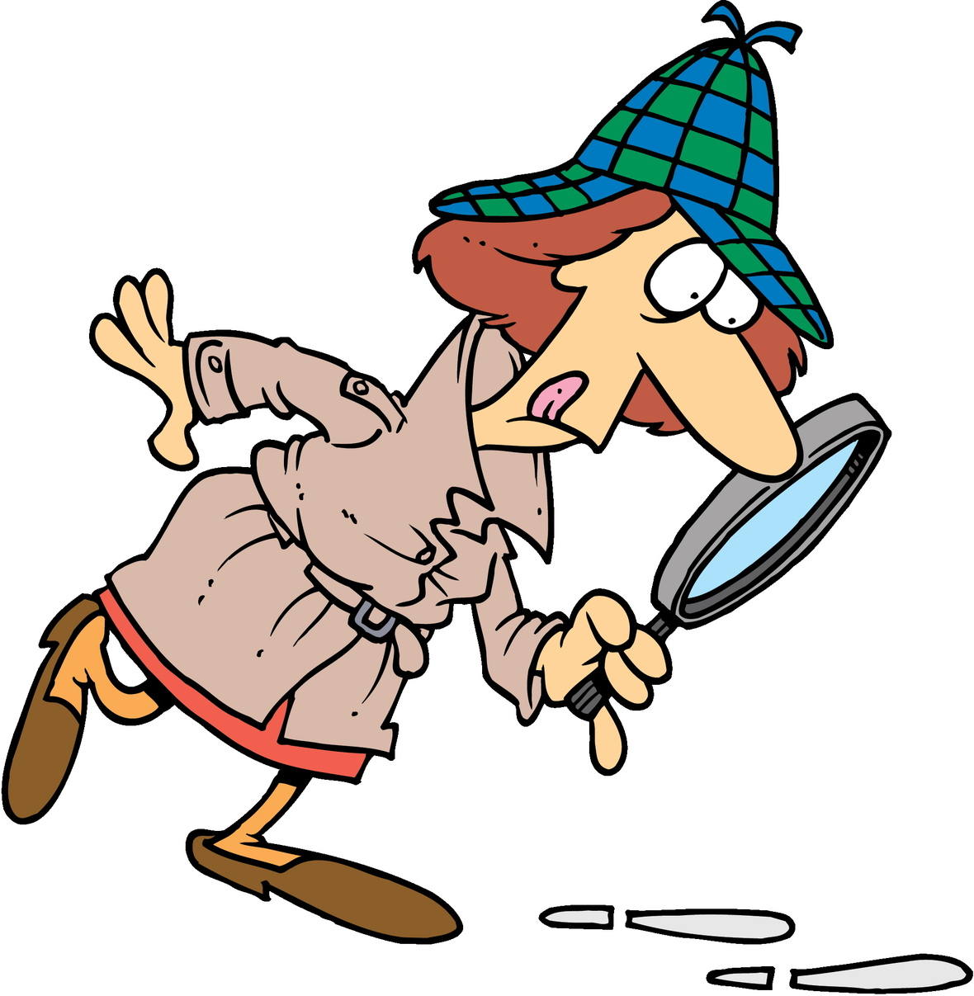
Emma Lees

The Learning Detective
I am a teacher. I work as a learning detective,

My job is to look for and collect clues about how a child/young person learns.
I collect the clues from teachers, from observing, from children and from activities. I usually also look in schoolbooks and sometimes sit in class

I will ask:
- What a child /young person is good at.
- What they find more difficult.
- How they think they learn best.
- What things they like and dislike.

I have tasks activities and games which I use to help me with my detective work.

Once I have collected clues, I work with school and help develop a plan to make sure that a child has the opportunities, resources and support they need to help them learn successfully and confidently in school.

What clues can Cluedo sniff out about me?
