Adding Childcare Provider pages to The Bury Directory

The Bury Directory www.theburydirectory.co.uk is an online information point where parents/carers in Bury can access childcare information.

It is a free service to use and a good way to showcase your setting and services you provide. If you a nursery who offer out of school care and holiday care, please add a record for each provision.

The Directory is an interactive tool, for optimal us of this resource you should open in either Google/Chrome or Microsoft Edge and accept all cookies

Thank you for using these instructions, if you have any queries regarding adding or updating your page please contact the Family Information Service on childinfo@bury.gov.uk. There is also a Help section where you can find bite size videos on how to add and update pages on The Bury Directory

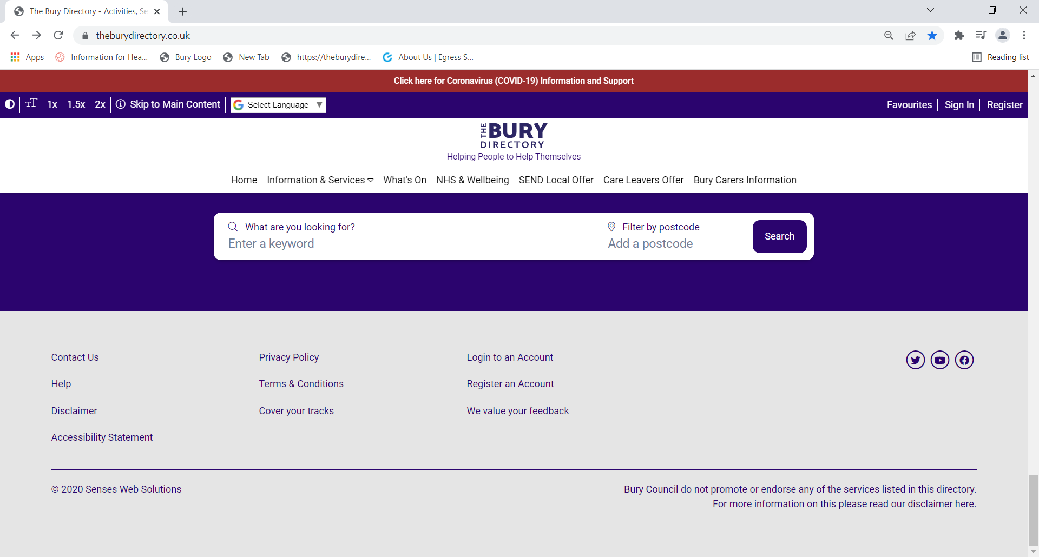

Contents Page

Registering an account P2
Logging into your account P2
Accessing ‘My Account’ P2
My Account dashboard P3
Creating a New page P3
General Info section P3
Target Groups + Facilities section P4
SEND Local Offer P4
Content and Media P4
Adding a logo, image or document P4
Communication Information P5
Select an existing Venue P5
Create new Venue P5
Social Media P5
Opening Times P6
Costs and Bookings P6
Carescheme Information P6
Early Childhood Development section P6
Submitting your entry P7
Updating your page P7

Registering an account

In most cases Bury’s Family Information Service will have added a page to the Bury Directory upon receipt your Provider Consent form which allows your information to be in the public domain. If your service page has not been added you would need to set up an account.

To Register an account, you would need to click on the Register button on the toolbar at the top of the page

This will open this form

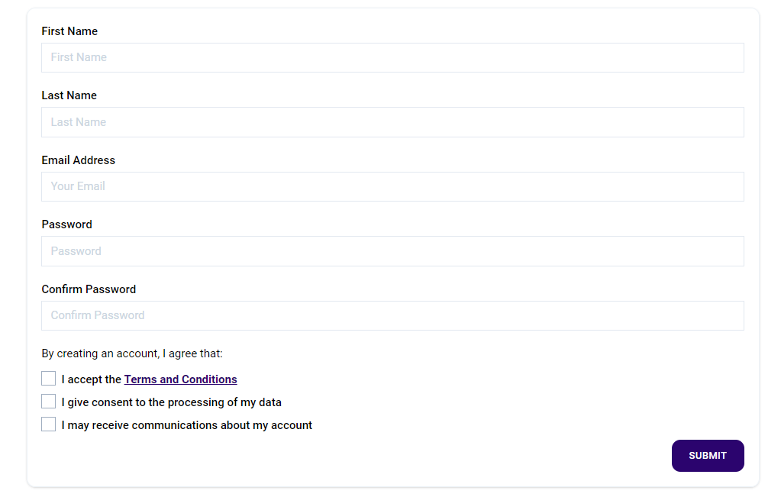

Please complete all fields including the Terms and Conditions, Consent and Communication boxes and press Submit. You will then receive an email to verify your email account. Once you have verified this you are able to Log in

Input the chosen email address and password, press Submit

The Log in tab at the top of the page will change to My Account

On the My Account click on the My Services tab if you already have a page set up it will appear here. If not you can create a new page by clicking on the Create a Service tab
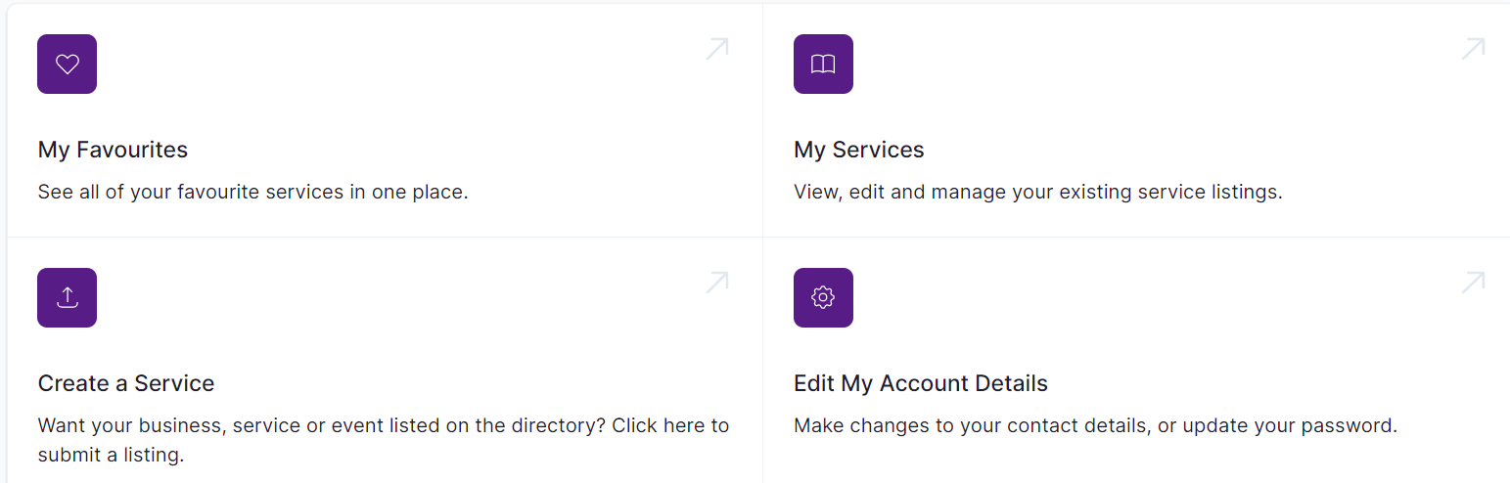

Creating a new page

The Service page is a basic page but dependent upon which tab/option you select various drop-down boxes will appear to be completed. Childcare providers will not need to complete all boxes. Only complete the boxes as shown

A new Submit a listing page will open – please see content below

Please note: When completing this form, the fields marked with an asterisk (*) are mandatory fields and need to be populated otherwise the document will not save.

General Info:

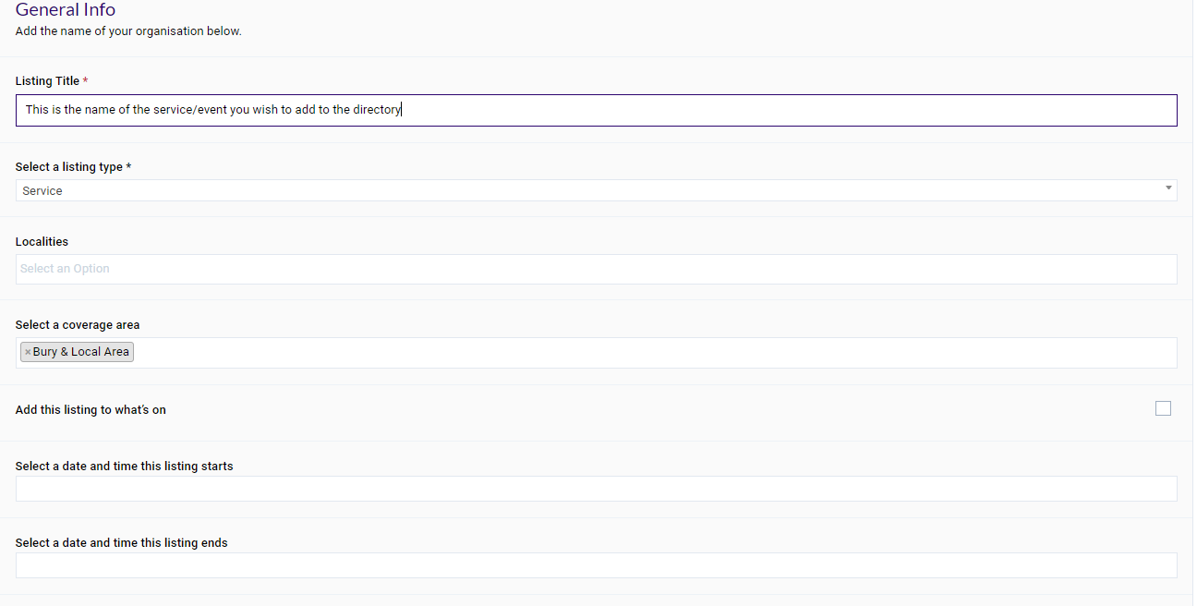

Listing Title: this is your or your Company name or if you are a childminder trading under another name please put both e.g. Freda Bloggs t/a Happy Childcare

Listing Type: as you are a childcare provider please select ‘Carescheme’. This opens the Carescheme and Early Childhood Development boxes at the bottom of the page (see page 6)

Localities: is where the service is based e.g. Prestwich, Bury East

Coverage Area: is area your service covers e.g. Prestwich, Bury East

‘What’s On’ and subsequent dates boxes – ignore this section as it is for an events page only

Keywords – this is the tagging section, add words you think people may use to search for your service/organisation. E.g. childcare, childminder, day nursery

Notes – You can also add any notes you may find useful for TBD staff e.g. which category you would like you page to appear in.

Target Groups & Facilities

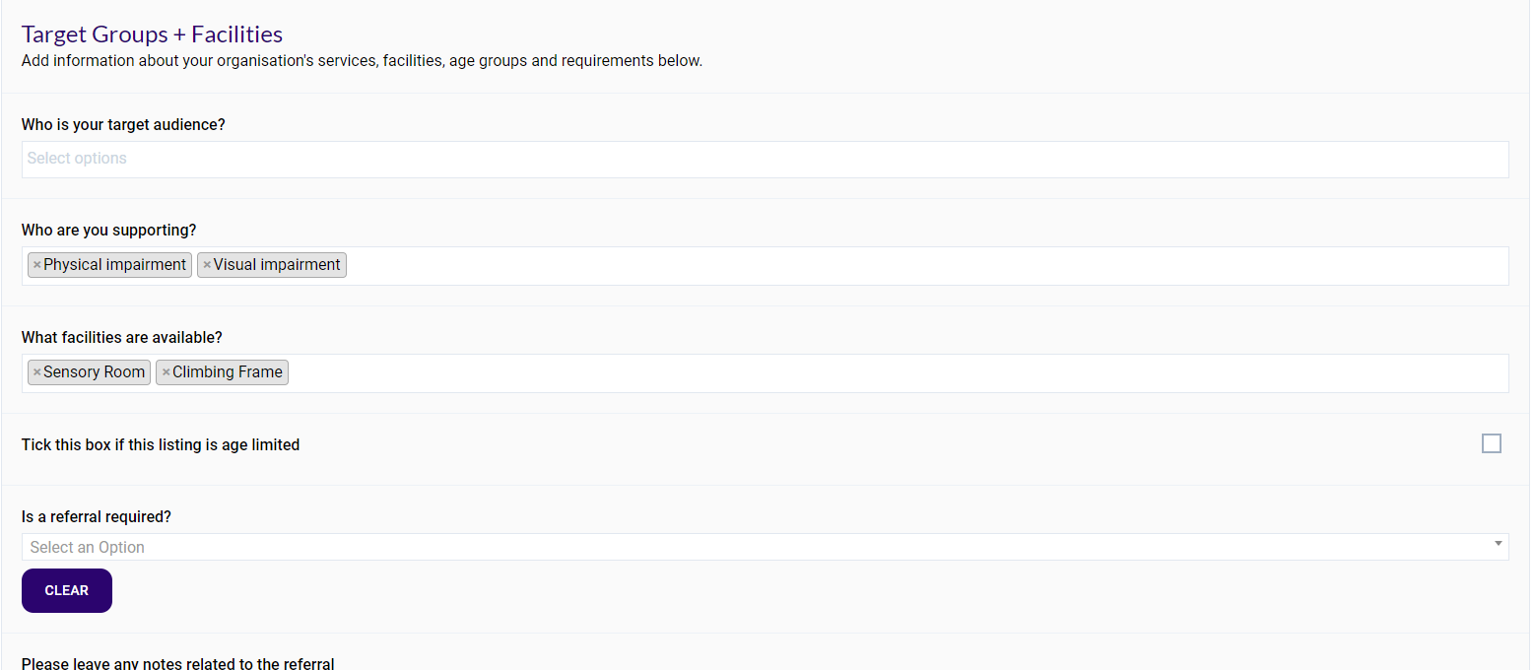

The following are filter questions, make selection(s) from the drop-down menu (you do not need to populate each section but you must complete the ones below)

What facilities are available? - To show what facilities are available at your setting e.g. Garden etc (there is a drop down list for you to choose from)

Is this a local offer? - Select ‘General’ from drop down list and complete the section outlining what your service offers to children and young people 0-25 with Special Educational Needs & Disabilities (SEND).

If not completed ‘I am/we are an inclusive provider and support children with Special Educational Needs and Disability (SEND), please contact me/us for further information’ will be added by a member of The Bury Directory Team

Content and Media

Describe your listing - is the Overview section on the live page, complete this box with a description of your service/organisation or event. You can put as much detail as you wish here to advertise your business (you could also include any extra availability or holiday cover in this section)

Adding a Logo, image or document

You can add your settings logo here (if you do not have a logo
The Bury Directory admin team will add a generic logo for you). You can add any documents you wish to add here e.g. pictures of you and your staff, flyers advertising your setting even youtube videos.

To add a logo, document or picture select the Upload button in the appropriate area. Please note only images/jpegs can be uploaded in the logo section

The following box will appear

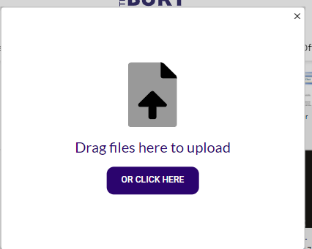

Drag and drop your image/documents to the Arrow or select the OR CLICK HERE. This will allow you to browse your devise for the image document and will download on to your page. If you wish to remove the image or document, simply click on it. It will stay in your gallery but not appear on the page

Communication Information

Complete the first set of boxes as this information shows as the contact details on your page.

Select an existing venue

The Bury Directory uses Google maps to show directions to your service or events to activate this function you would need to Select existing venue option and type in the first couple of letters for your address. If your address is already on the system, it will show in the drop-down list

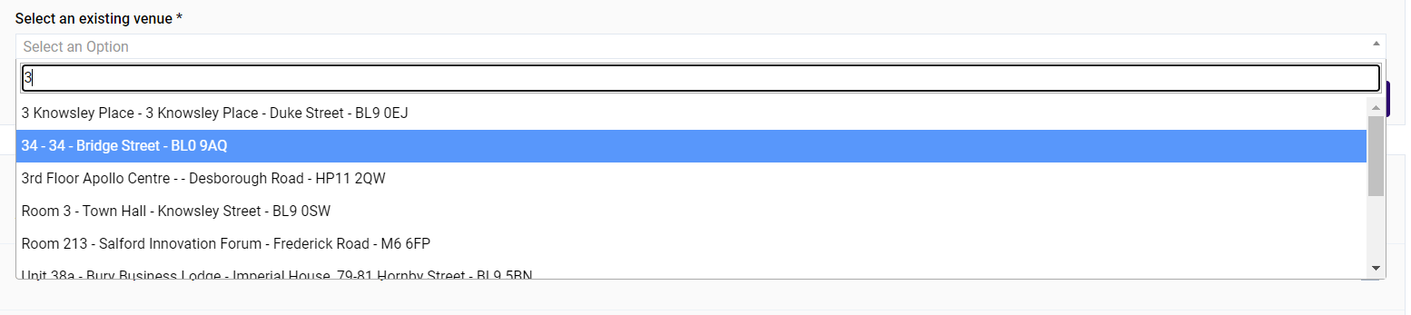

If your address is not in the drop-down section, you will need to create a new record.
Please note: If you would prefer only part of your postal address is published (suppressed address) please ensure you put this in the ‘address’ box (a member of the Bury Directory team will then action).
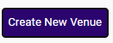
Click on Create New Venue button

This will open a new box, please complete all fields marked with an asterisk (*) and click on Select Venue

Social Media

Complete any social media boxes you would like to add to your page. This will show on the Contacts section of the live page

Links – complete this with the links (and titles) of any pages/resources you would like to link to. To add links simply click on the + button (you can add multiple links). This shows in the Links section on the live page.

Opening Times - Complete boxes as appropriate

Date details – this could be a singular date or e.g. Monday to Friday 8.00 am until 4.00pm.

Additional time and date info – this could be term time only

Costs and Bookings – This information is optional – if not completed ‘please contact provider for details’ will be added

Carescheme

30 Hours: - Mark this box if are offering the 30 hours childcare for 3&4 year old option

Tax Free Childcare - Mark this box if you are registered to accept tax free childcare payments

30 Hour partner summary – complete this box with the name of the childcare provider/school you are working with

Early Childhood development

Cultural provision, Dietary requirements and Special needs provision are inclusion information so must be completed – if you do not have any experience simply place a tick the box(es). If you have experience, please select from drop down menu, you can also provide written details in the additional details boxes

Wheelchair access - If you have wheelchair access, please let us know which type in the details section of this question

School Pickups - If you provide a school drop off/pick up service you can select which schools from the drop-down list, if you drop off/pick up from any other type of childcare provider put the names in the details box (a member of the Bury Directory team will then action)

Funded places - Only complete this if you are on the approved list for 2,3 & 4year old EEC funded children

Submitting your entry
Once you have completed your form click the button.
Your page will then show as until a member of the Bury Directory Team accepts your entry. Your page will show as and be ‘live’ on The Bury Directory.

Please Note:

Should any of your information change it is your responsibility to update your profile. It is your responsibility to ensure your information is kept up to date and accurate. We reserve the right to remove your details from our web information if your details have not been updated for 12 months. This means your details will not be available to the public and not included in Family Information Services childcare searches.

Updating your page

To update your page, you would log in as normal, on the Dashboard select the entry which needs to be amended

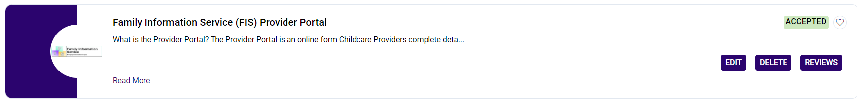

Please note: If you click on the title of the page this will take you to the ‘live’ page on the Bury Directory.

To Edit your page, click on the Edit tab. You are then able to amend your details. Once you have completed your amendments click
Your page will then show as until a member of the Bury Directory Team accepts your entry. Your page will show as and your amendments will be ‘live’ on The Bury Directory.

If you have problems accessing/updating your pages or any queries contact Janet Watts, Family Information Service on 0161 253 5941 email: childinfo@bury.gov.uk

